**TEST SUMARRY**

**AUT:** <https://qa-task.backbasecloud.com/>.

"BBlog" is a social blogging site (i.e. a Medium.com clone).

There are General functionality which is listed below

* CRUD Articles
* CR*D Comments on articles (no updating required)
* GET and display paginated lists of articles
* Favorite articles
* Follow other users

### SCOPE OF TESTING

* To test the BBLOG website CRUD ARTICLE functionality will be in Scope as its major functionality of BBLOG website.
* Other general functionality will be Out of scope.
* As BBLOG Requirement spec focus will be on Manual Test and UI Automation.
* Will be performing SYSTEM TEST.
* Testing will be done in Chrome.

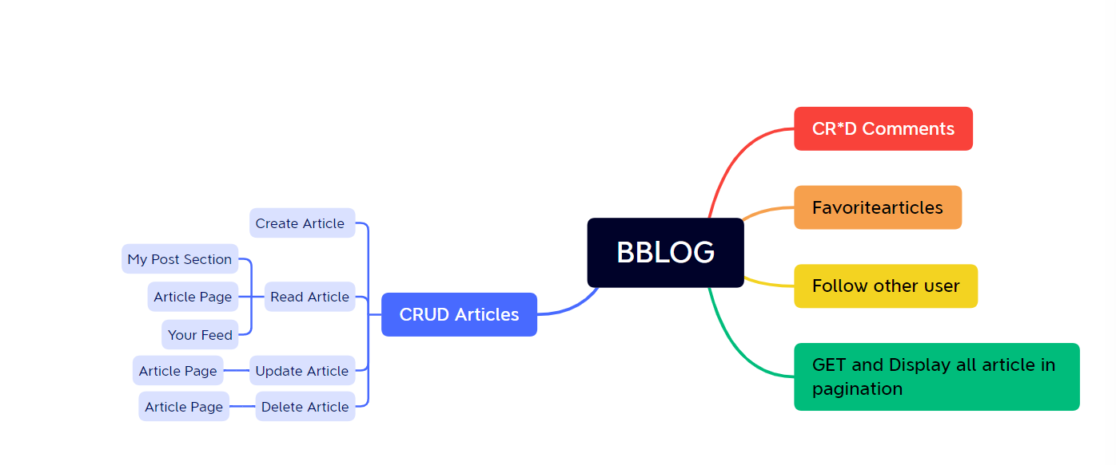

This session we have targeted to test CRUD ARTICLE FUNCTIONALITY with Manual and Automate test.

**TESTING REPORT :**

|  |  |  |  |  |
| --- | --- | --- | --- | --- |
| **Functions** | **Test Executed** | **Test Passed** | **Pass Percentage** | **Remarks** |
| Create Article | 10 | 5 | 50% | w.r.t Fucntionality its working but negative  scenarions need to be handled |
| Update Article | 8 | 5 | 62.50% | w.r.t Fucntionality its working but negative scenarions need to be handled |
| Delete Article | 2 | 2 | 100% |  |

|  |  |  |  |
| --- | --- | --- | --- |
| **Manual Test** | | | |
| **Total** | **Pass** | **Fail** | **Bug raised** |
| 20 | 10 | 10 | 8 |

|  |  |  |
| --- | --- | --- |
| **Automation Test** | | |
| **Total** | **Pass** | **Fail** |
| 7 | 7 | 0 |

**Automation report**



**Automation:**

* We have used TypeScript with Playwright tool
* We have Automated End to End scenario with Create article and read data, Update article and read data and Delete Article which give beter ROI as these are the major & main functionality of BBLOG application.
* Total 7 manual cases automated and covered in 2 test of automation.
* Remaining manual test case once we have a fix for filed level validation we can increase coverage

**Recommendations:**

1. Edit and delete option should be present once on article a page
2. Over update article page Button name should be displayed as Update article.
3. Suggestion : We can introduce mandatory filed check and if any of the mandatory filed is blank throw an error

**Environment Configuration**

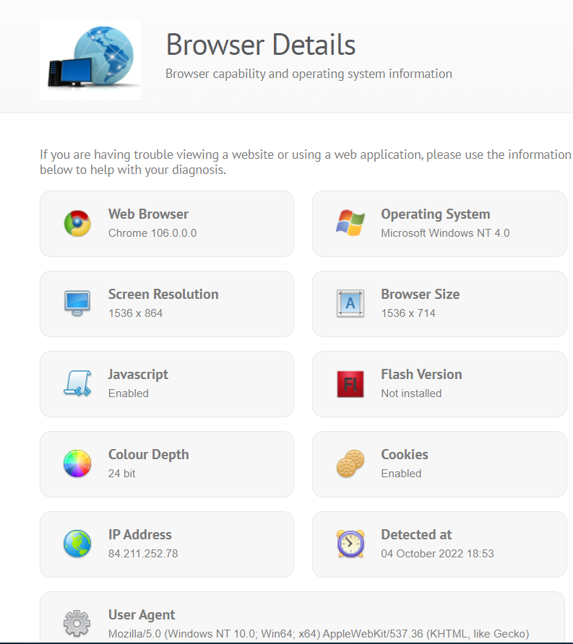

**BUGS**

**BUG_01_ABLE TO CREATE ARTICLE WITH ALL FILED AS BLANK**

**STEPS TO REPRODUCE:**

1. **Login to application**
2. **Click on New Article link**
3. **Without filling any field click on publish article button**

**ACTUAL:** Able to create article without filling any data

**EXPECTED:** Should not allow if filed is blank

**PRIORITY: High**

**SEVERITY: low**

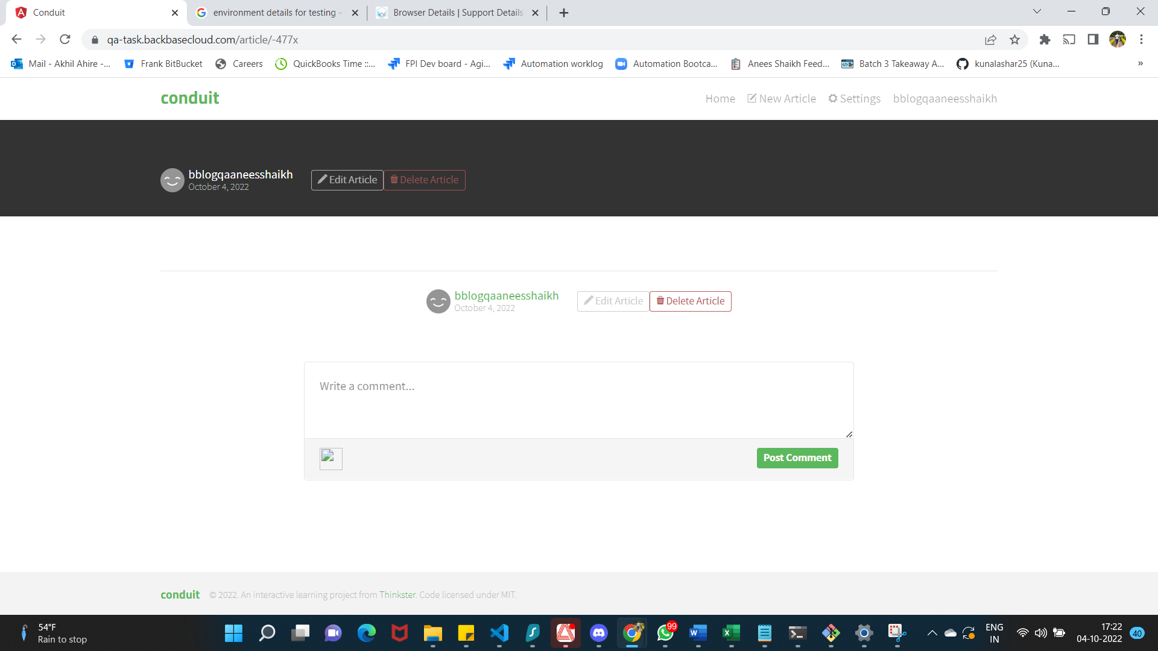

**BUG_02_RFRESH OVER CREATE NEW ARTICLE PAGE GIVE 404 error**

**STEPS TO REPRODUCE:**

**ACTUAL:** Getting 404 error over refresh or reload

**EXPECTED:** Create new article page should be reloaded

**PRIORITY: Medium**

**SEVERITY: Medium**

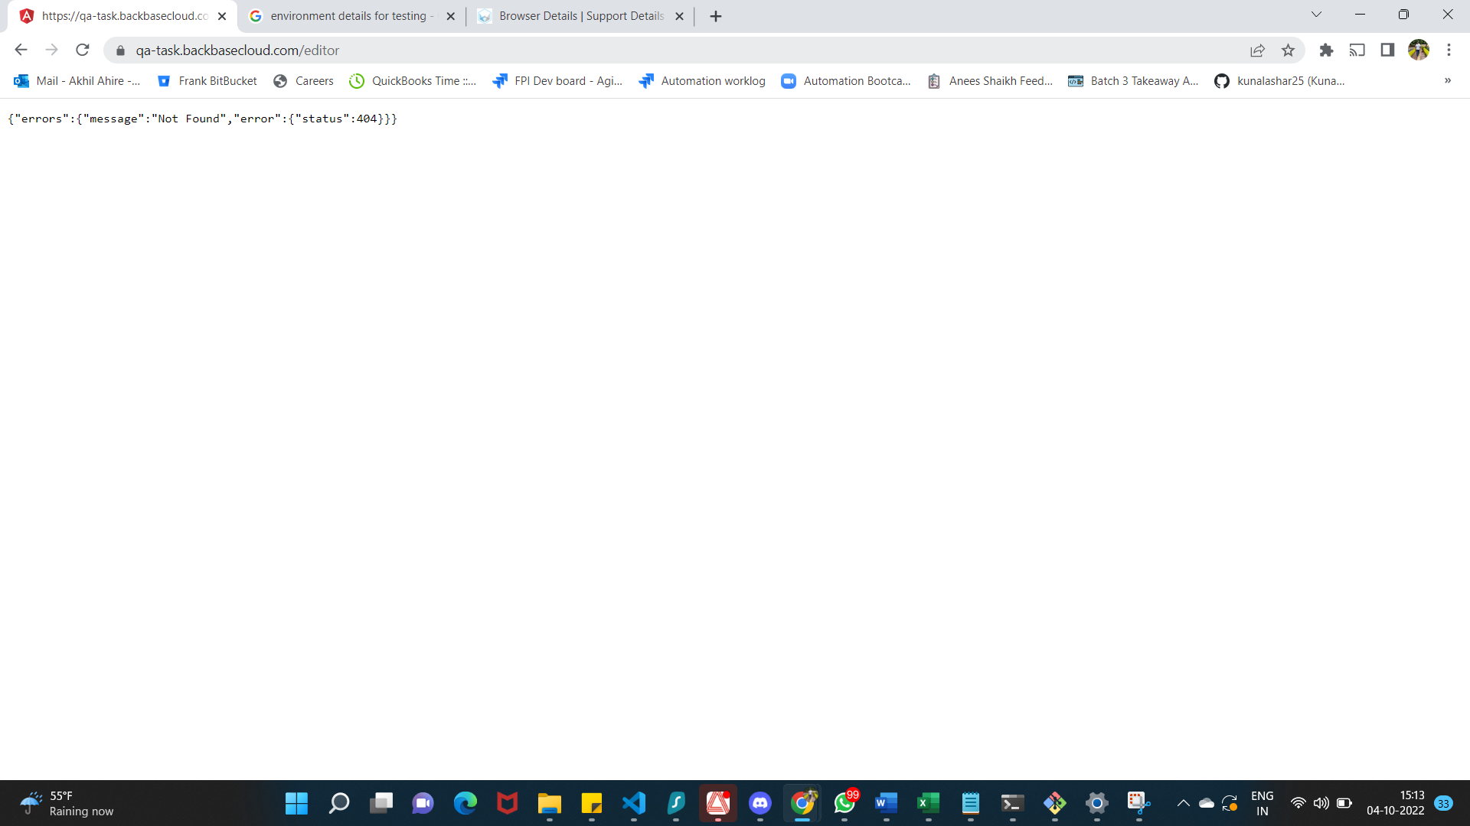

**BUG_03_** **No error displayed if any filed is blank and user try to click on publish article button**

**STEPS TO REPRODUCE:**

1. **Login to application**
2. **Click on New article link**
3. **Fill all filed except title field (repeat similar steps for other fields)**
4. **Click on publish article**

**ACTUAL:** Field specific error is not displayed instead it got updated with blank value

**EXPECTED:** Field specific error should be thrown for blank values

**PRIORITY: Medium**

**SEVERITY: low**



**BUG_04_** **Your feed section over home page is not displaying created or updated articles**

**STEPS TO REPRODUCE:**

1. **Login to application**
2. **Create New Article**
3. **Click on Home page**
4. **Click on your Feed Section**

**ACTUAL:** Article are not getting displayed in Your Feed section of Home page

**EXPECTED:** Article should get displayed in Your Feed section of Home pagew.r.t logged in user

**PRIORITY: High**

**SEVERITY: Medium**

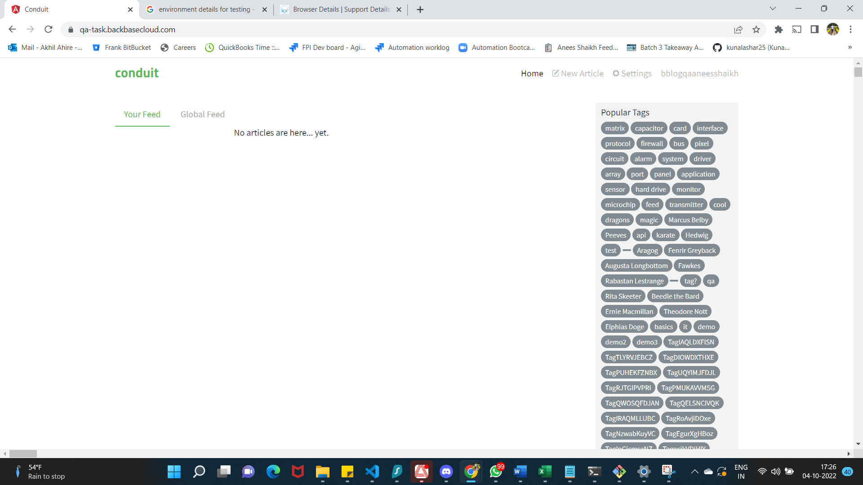

**BUG_05_** **Article Title Text or Body text is not wrapped on article page**

**STEPS TO REPRODUCE:**

1. **Login to application**
2. **Crate article with long title**

**ACTUAL:** Text wrapping is not done properly over article page it looks weird if article is having long words of characters in title

**EXPECTED:** Article Title text should be wrapped in proper way before displaying it

**PRIORITY: Medium**

**SEVERITY: Low**

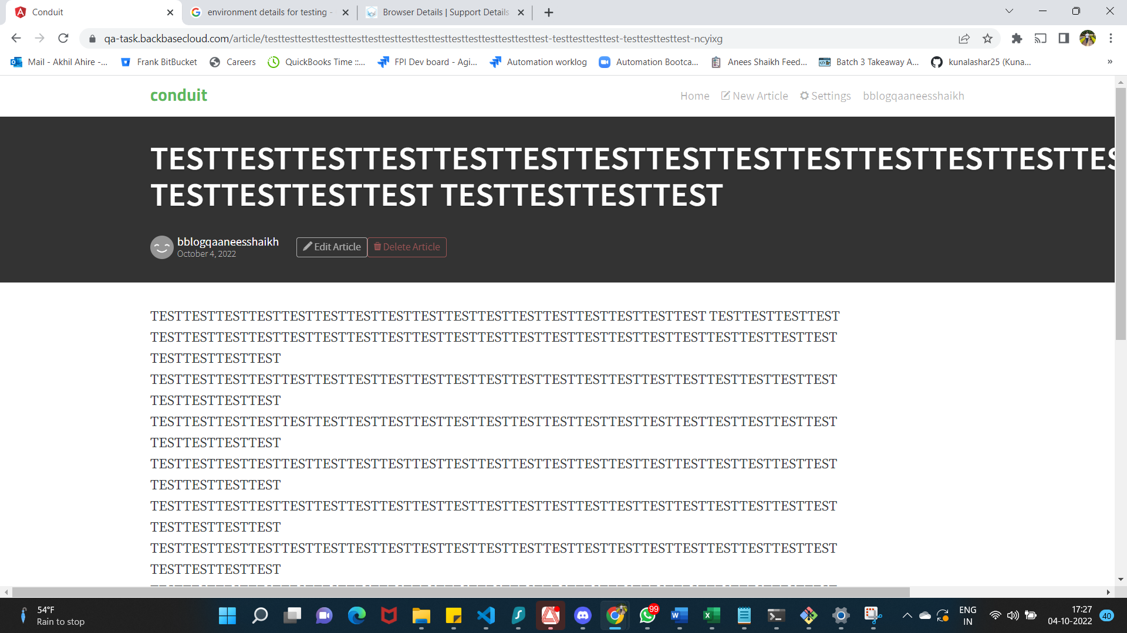

**BUG_07_** **Character length is not defined for each text box present over create article page**

**STEPS TO REPRODUCE:**

1. **Login to application**
2. **Click on New article link**
3. **Enter Text in Title filed**

**ACTUAL:** User is able to enter N number of words and character over text box

**EXPECTED:** Text box character limit should be defined for each text box

**PRIORITY: Medium**

**SEVERITY: Low**

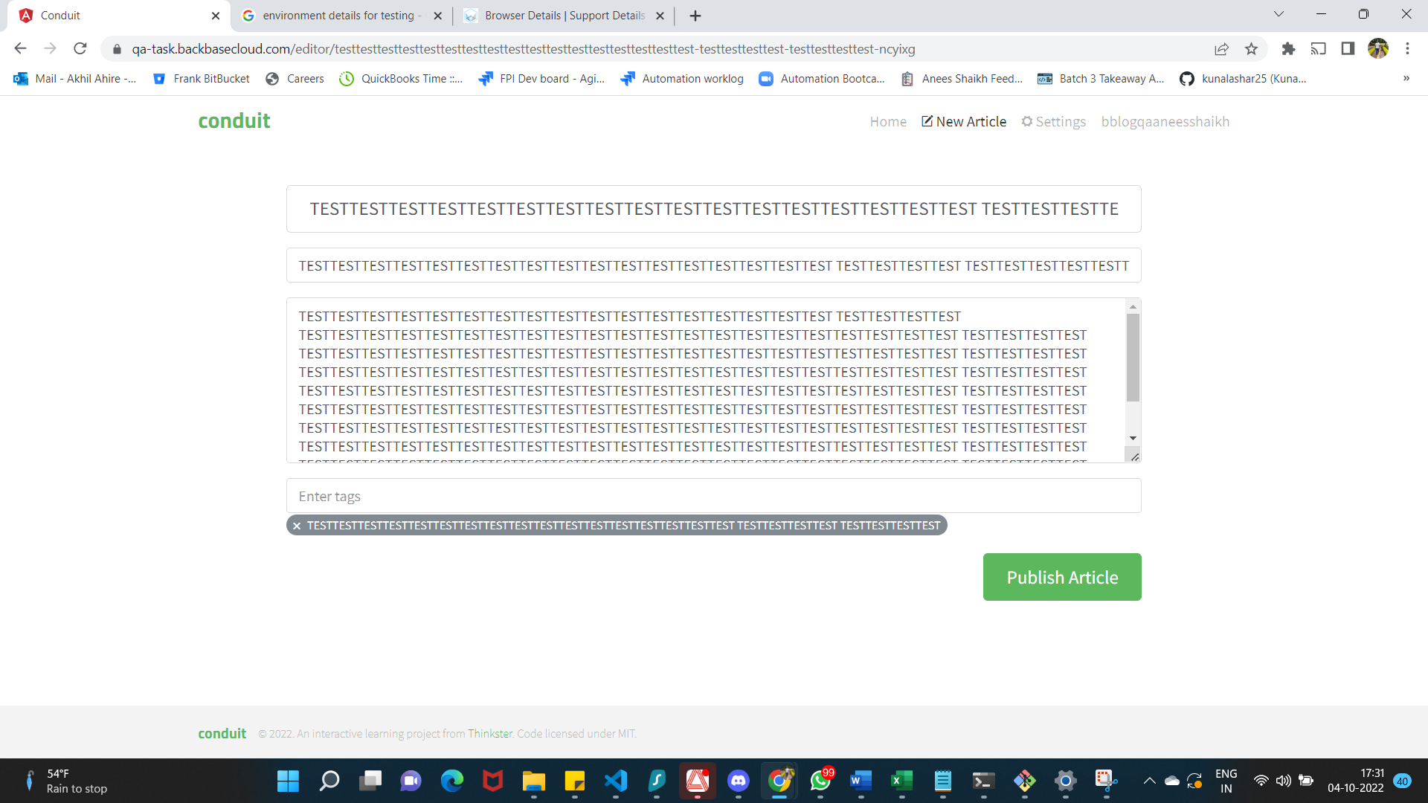

**BUG_08_** **Page is not responsive over mobile emulators or mobile devices**

**STEPS TO REPRODUCE:**

1. **Load application in mobile emulator or device**

**Actual:** Page is not getting loaded as expected in mobile its not responsive

**EXPECTED:** Page should be responsive in Mobile emulator or devices

**PRIORITY: Medium**

**SEVERITY: Low**

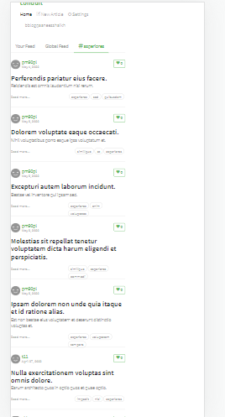

**TEST EVIDENCE**

**TC_CA_001**

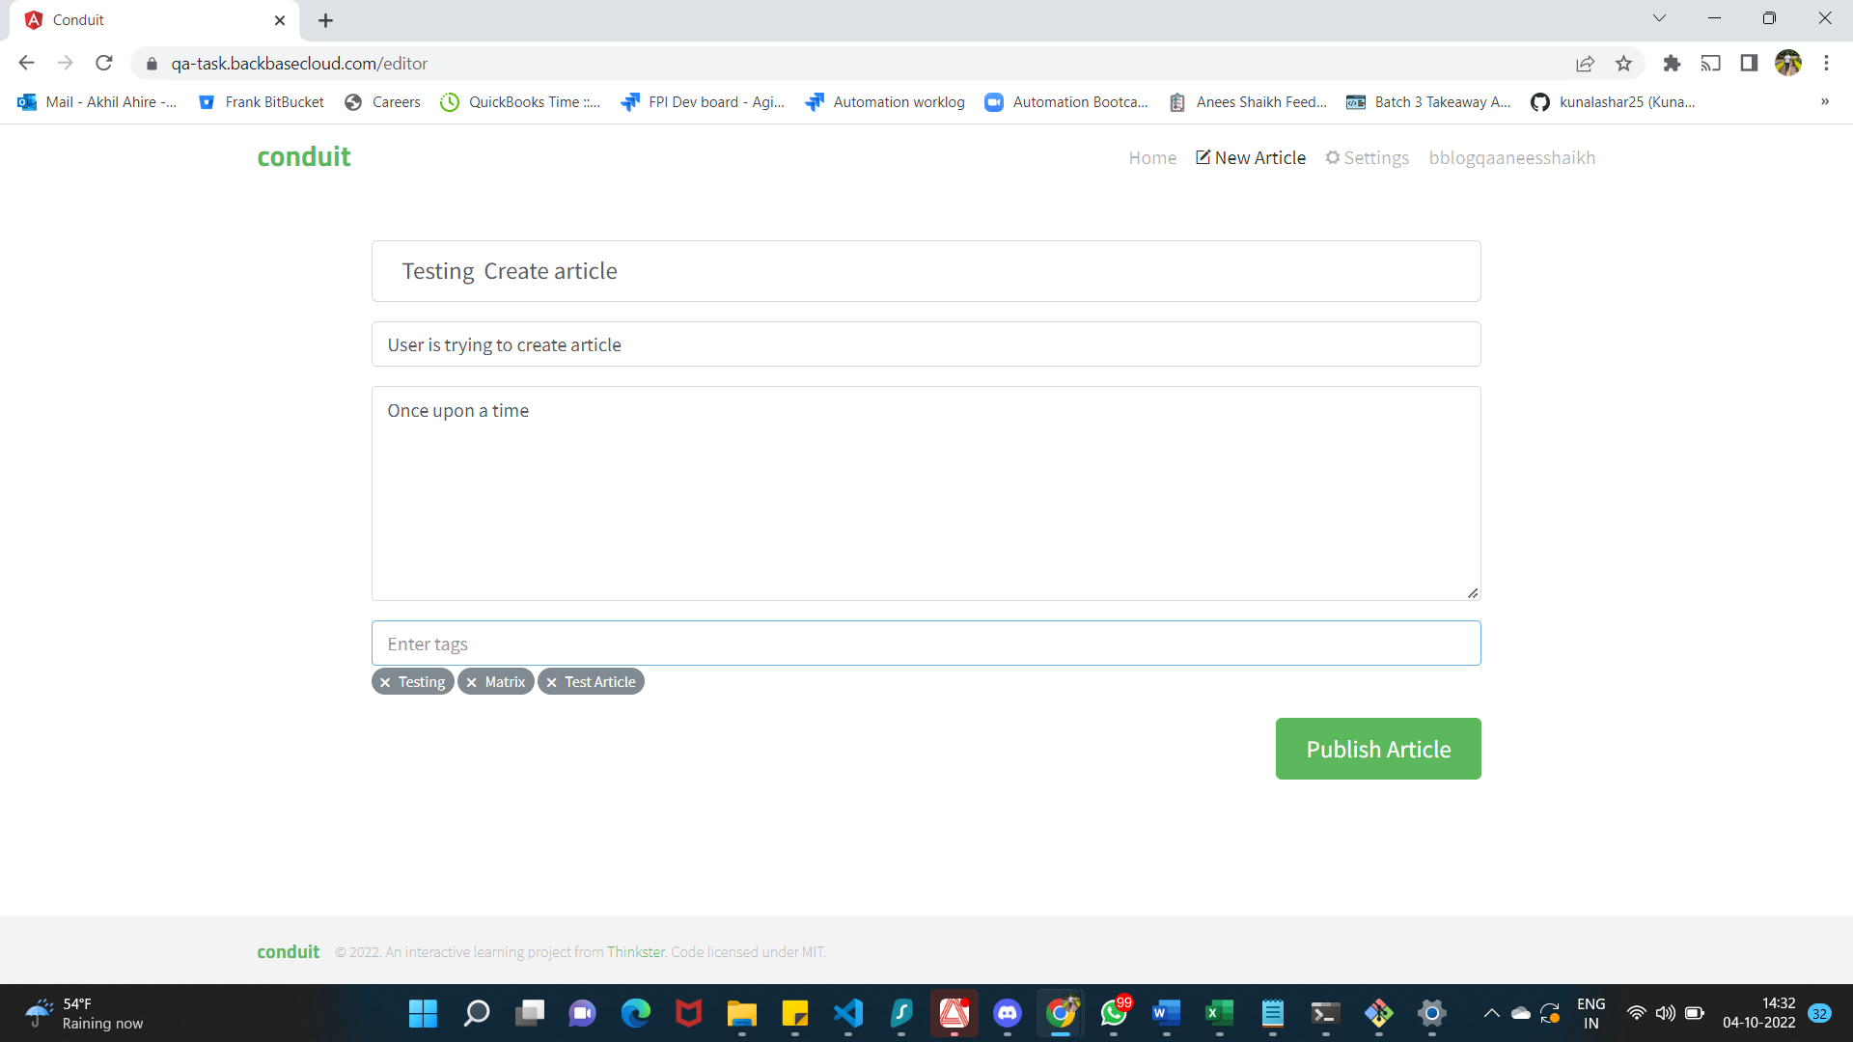

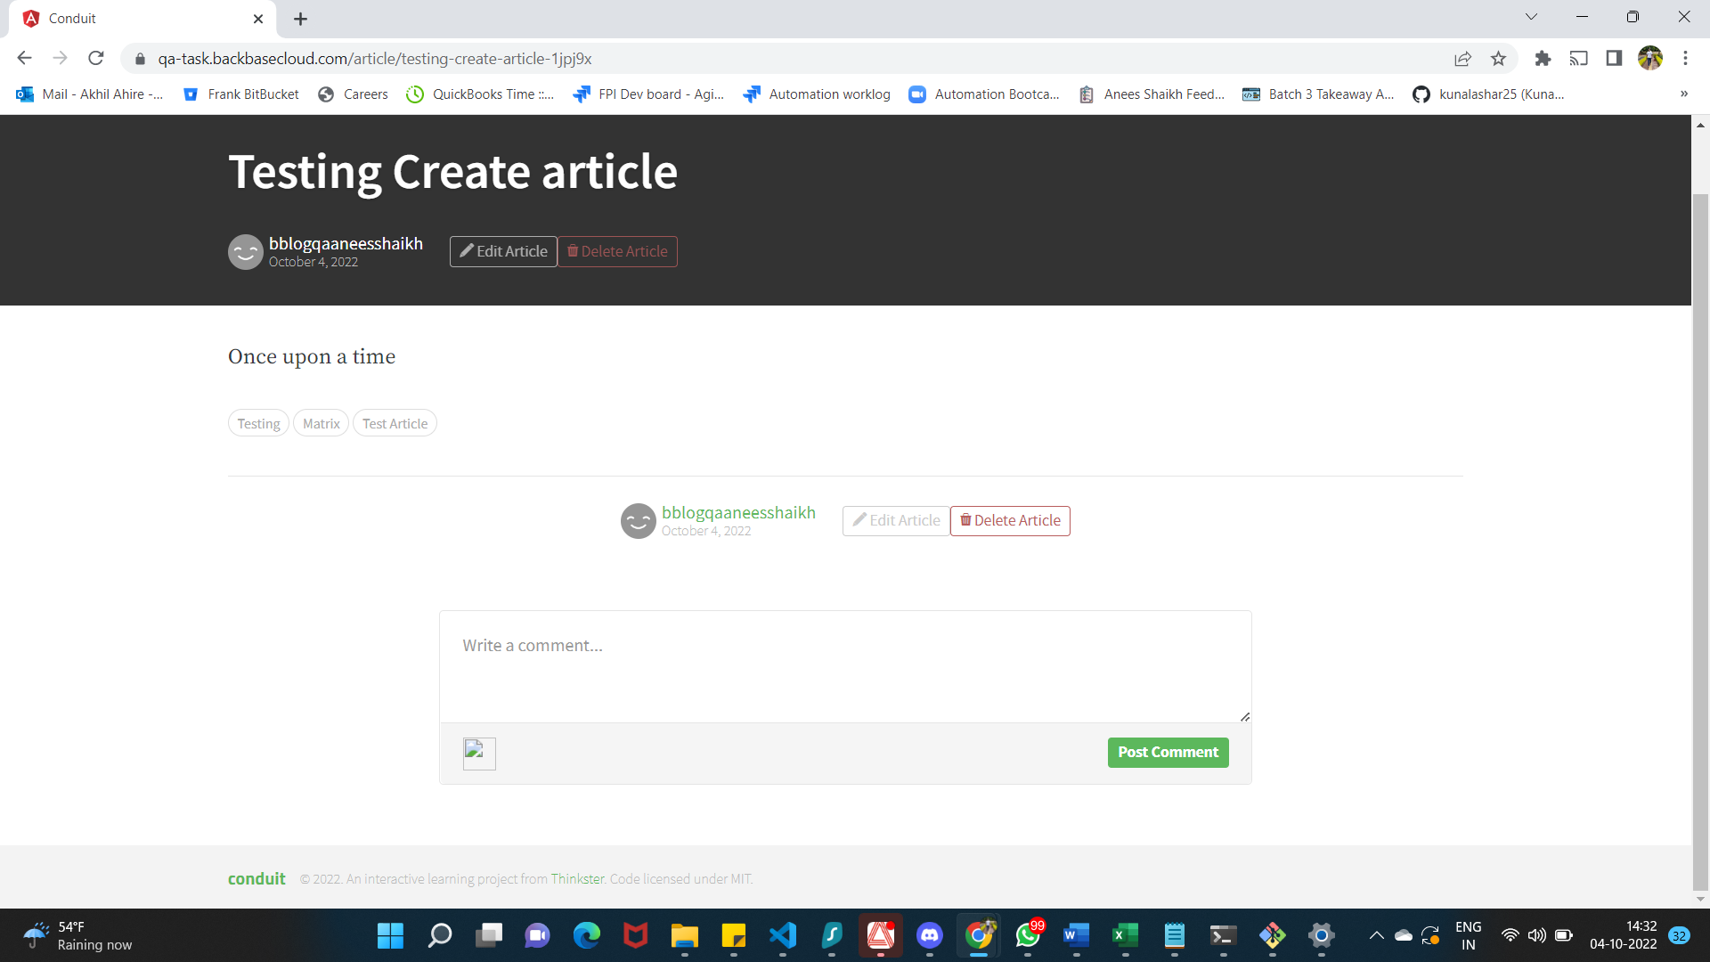

**TC_CA_002**

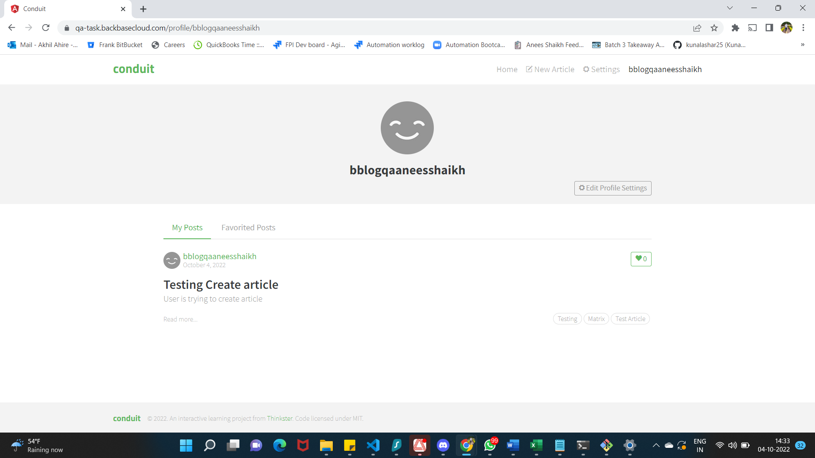

**TC_CA_003**

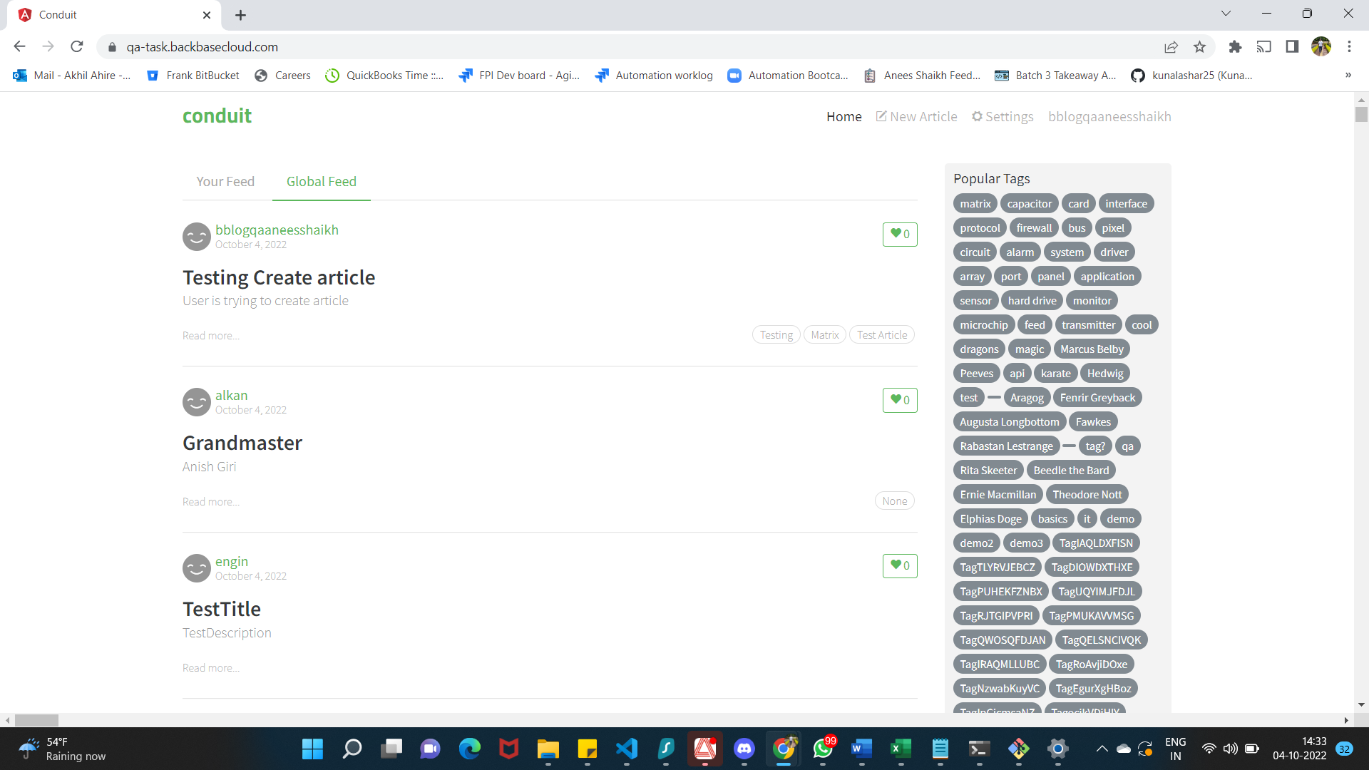

**TC_CA_004**

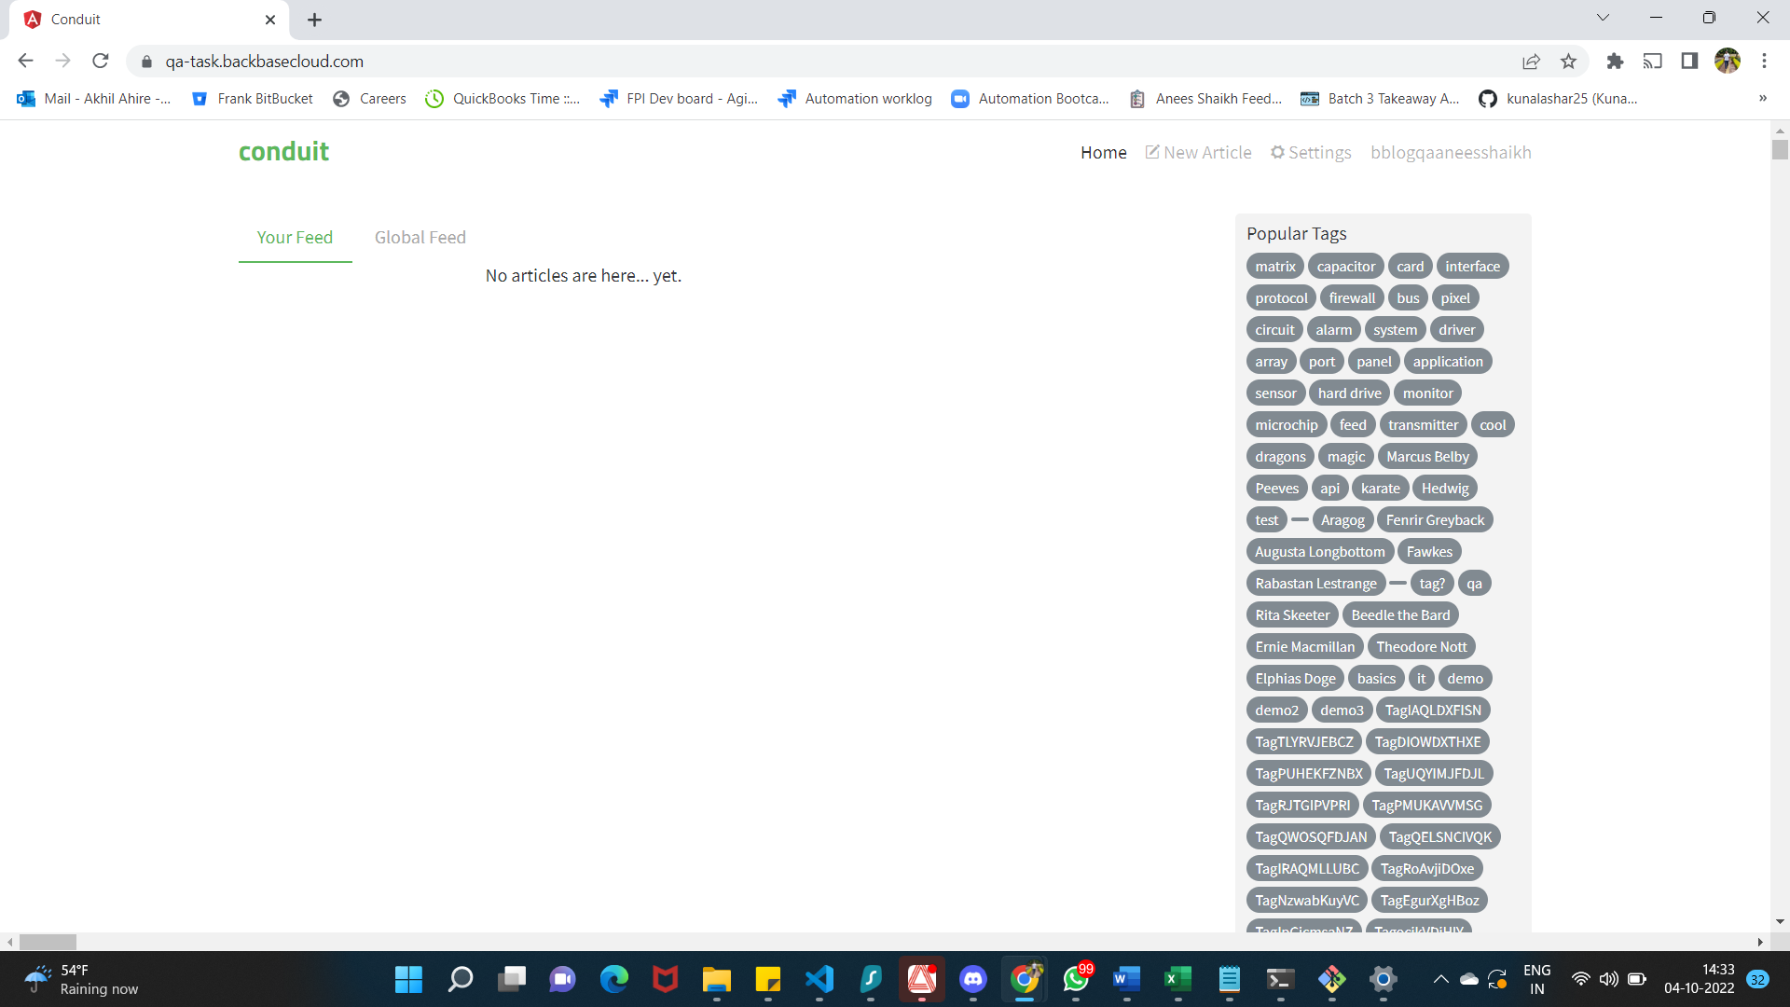

**FAILED BUG_04**

**TC_CA_005**

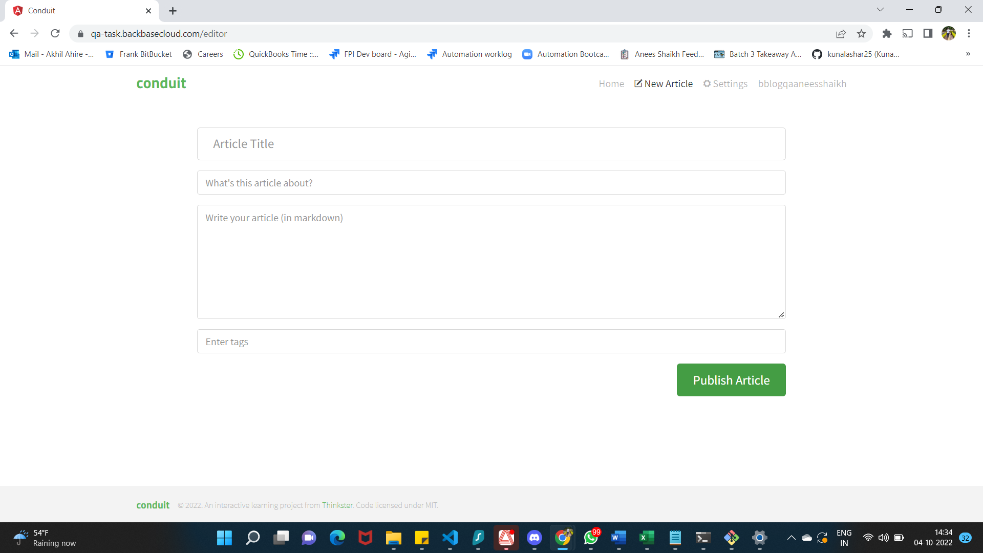

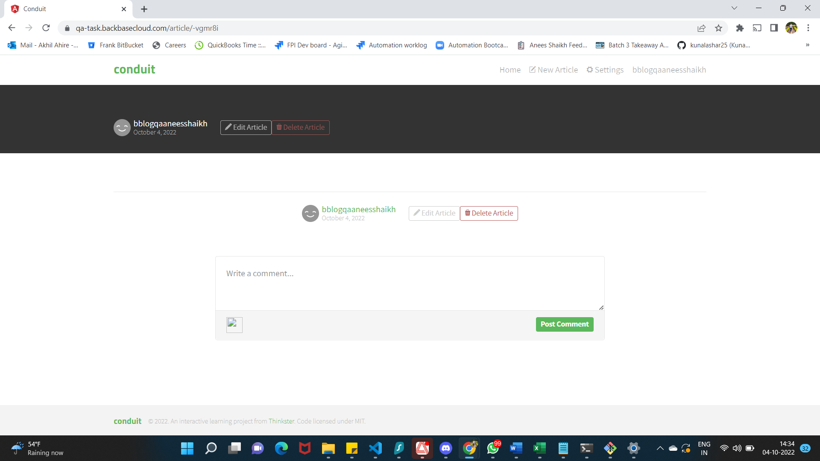

**FAILED BUG_01**

**TC_CA_006**

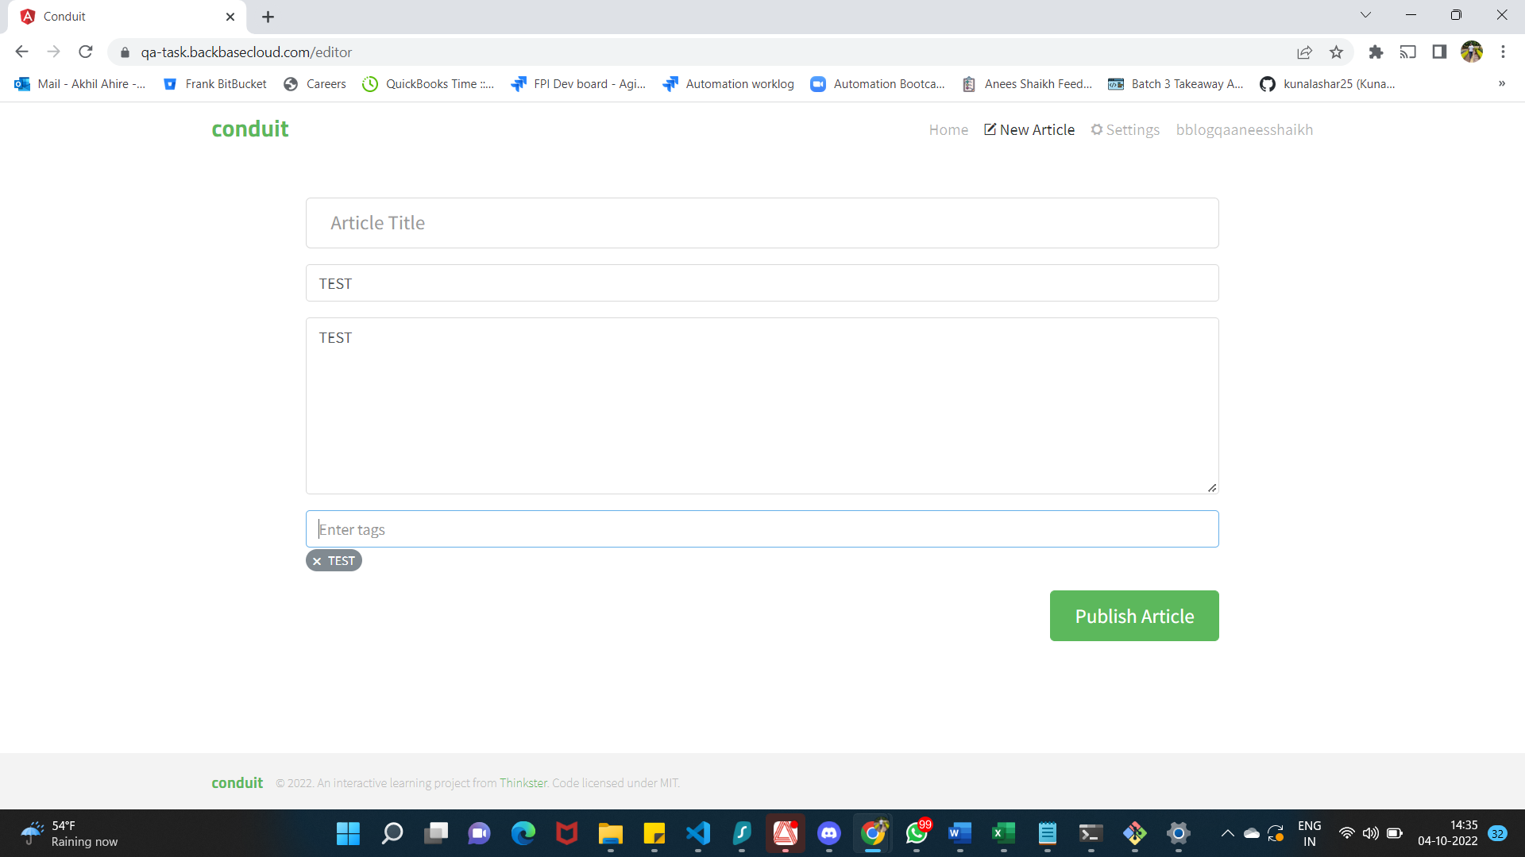

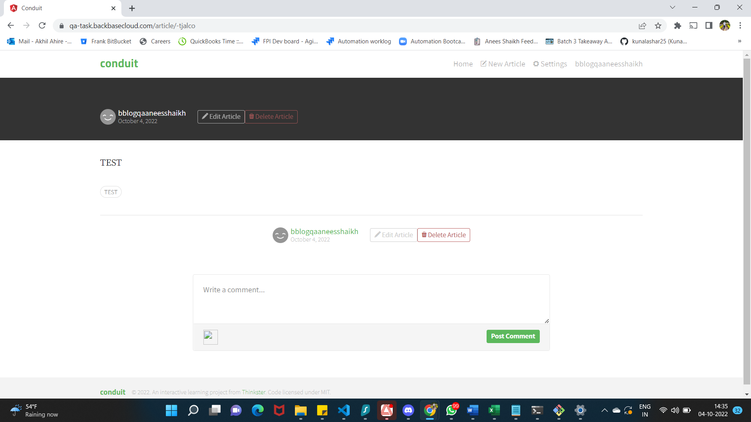

**FAILED BUG_03**

**TC_CA_008**

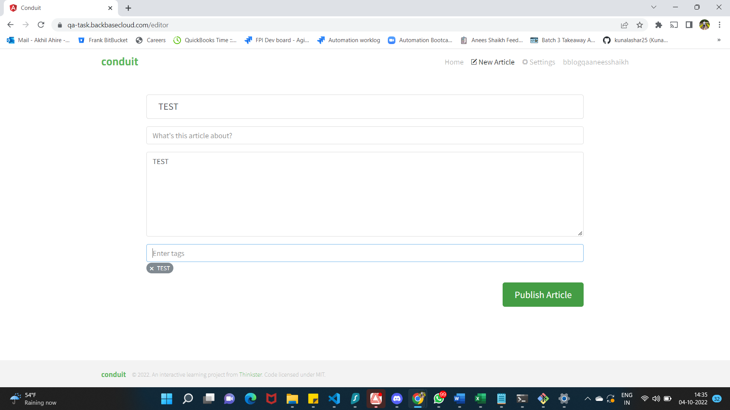

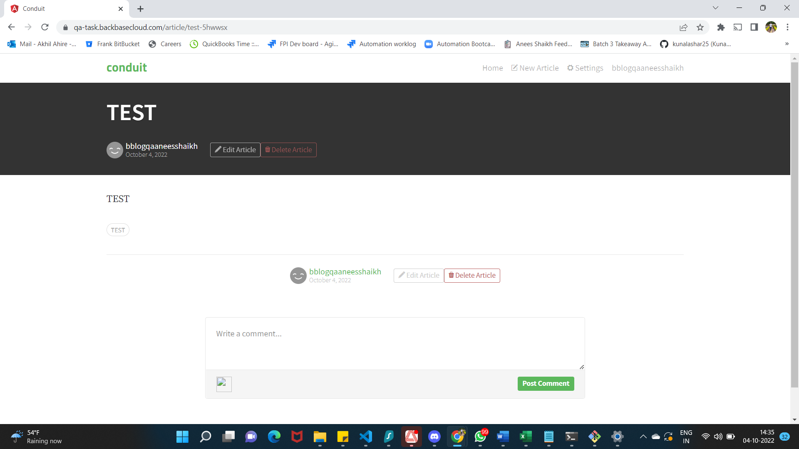 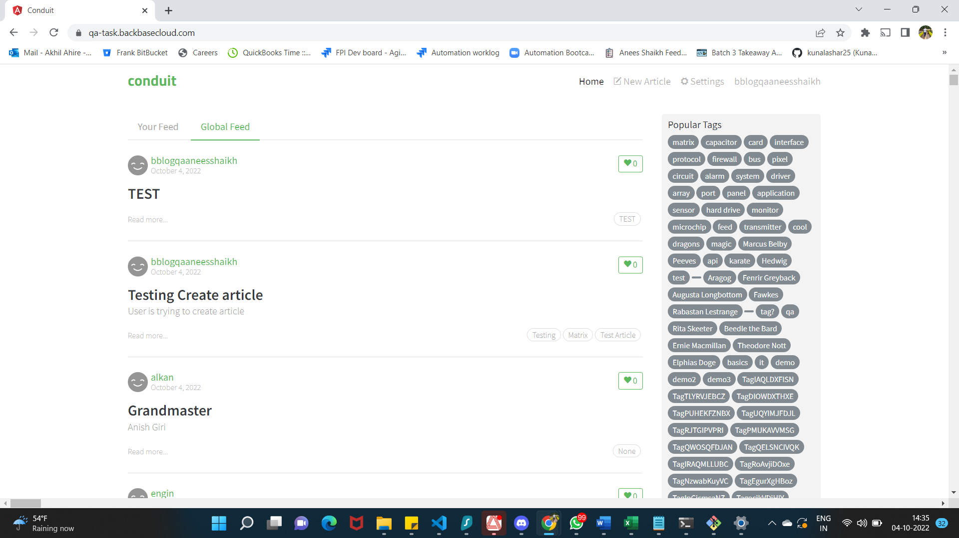

**FAILED BUG_03**

**TC_CA_007**

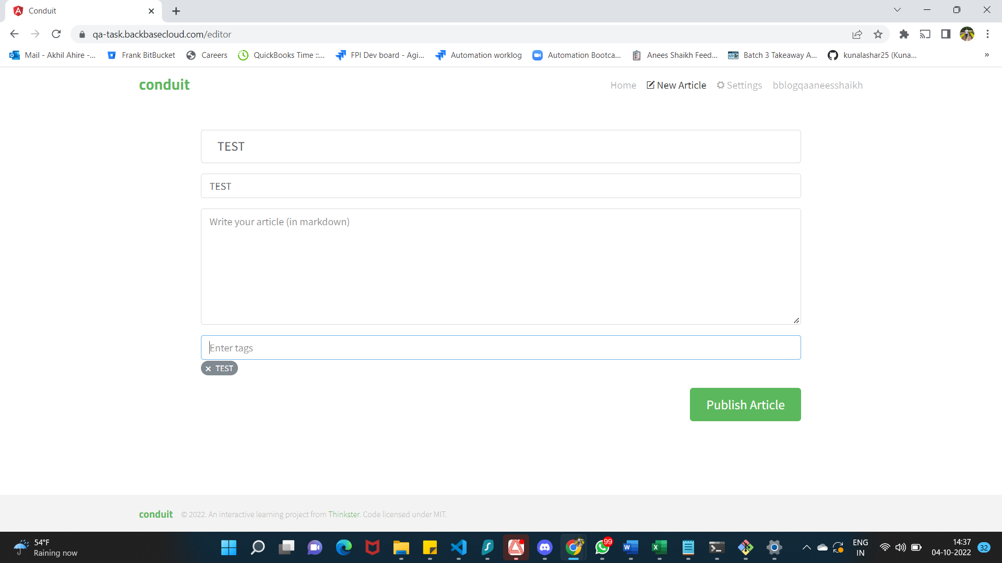 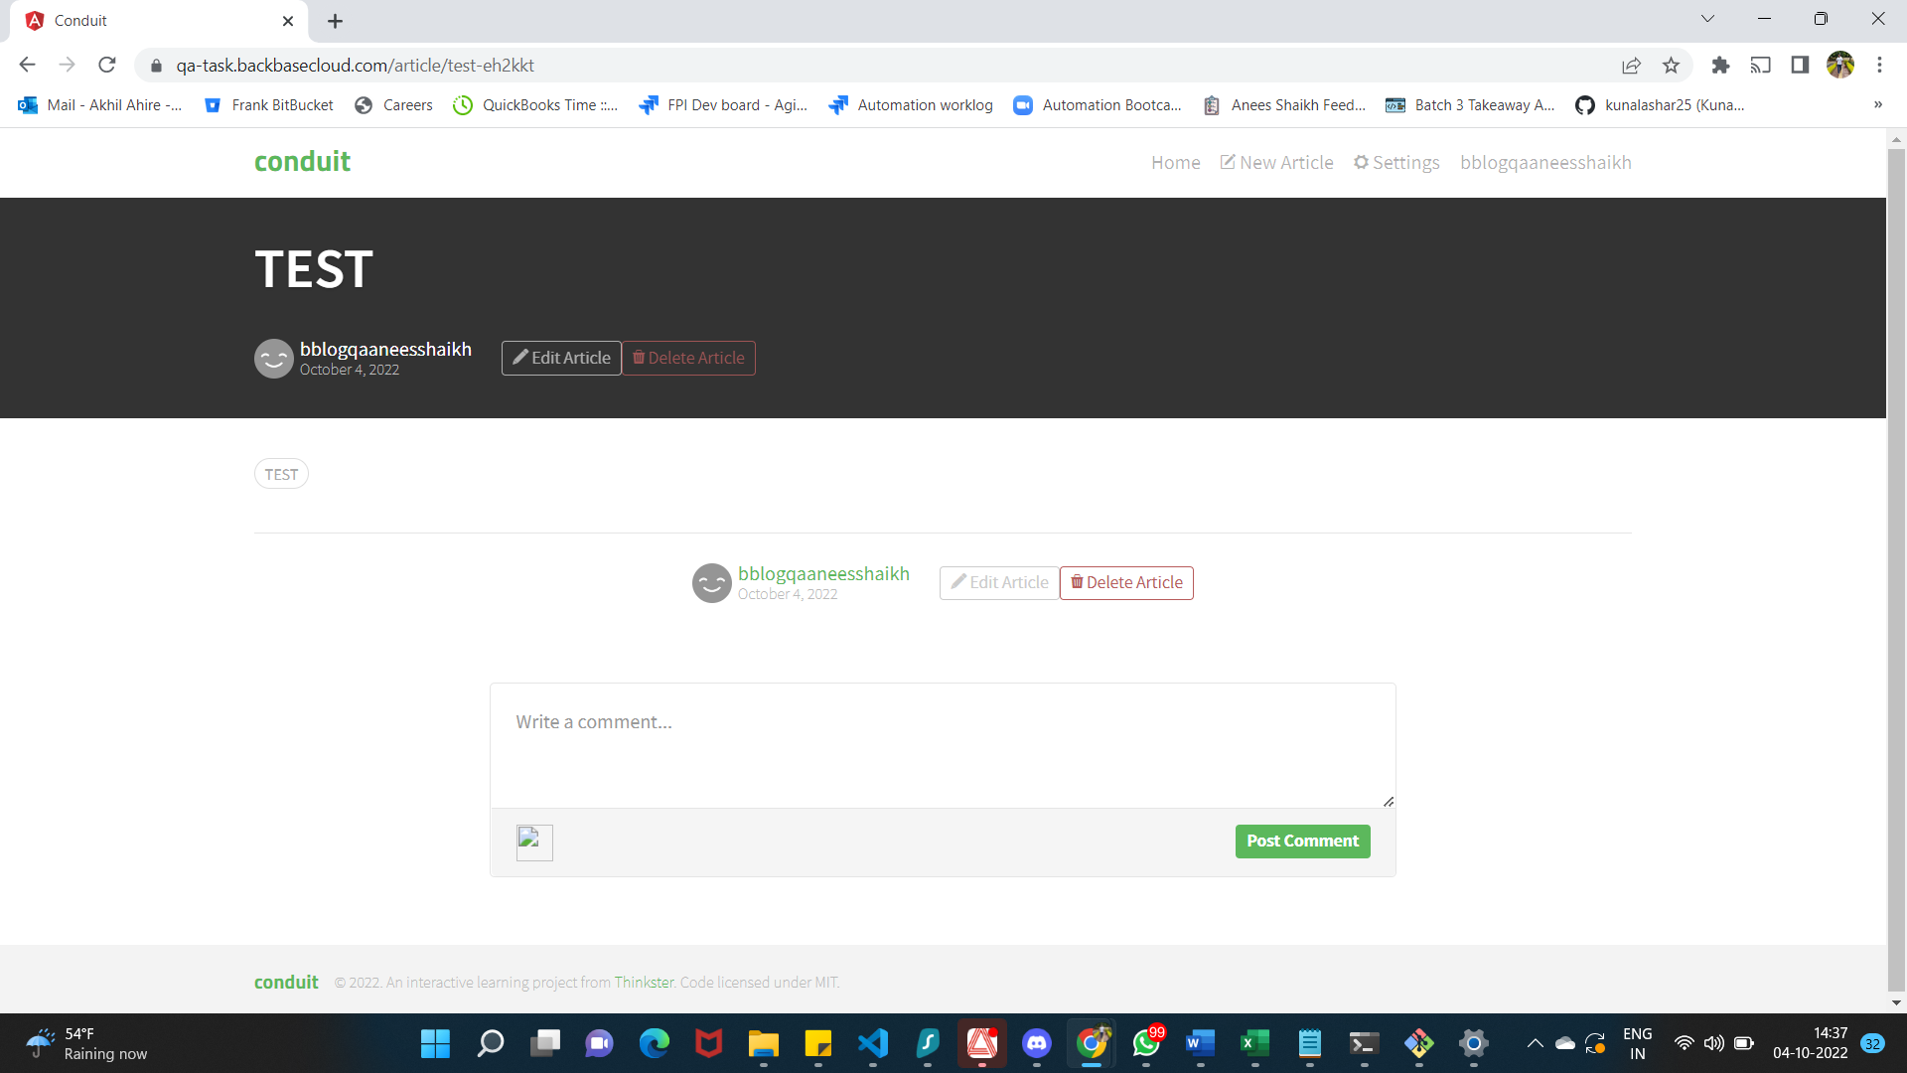

**FAILED BUG_03**

**TC_CA_009**

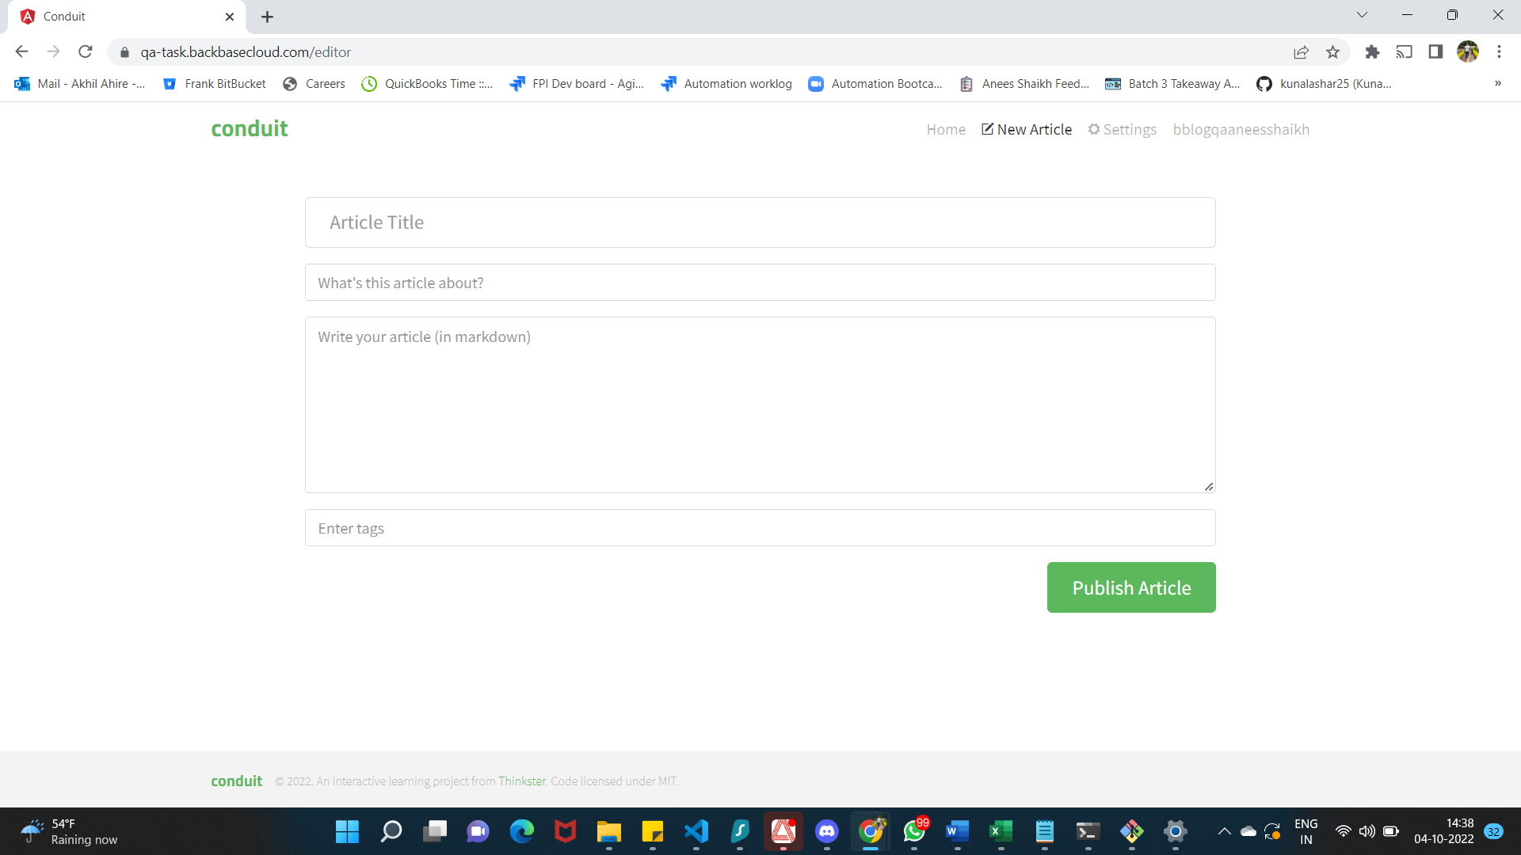

**TC_CA_010**

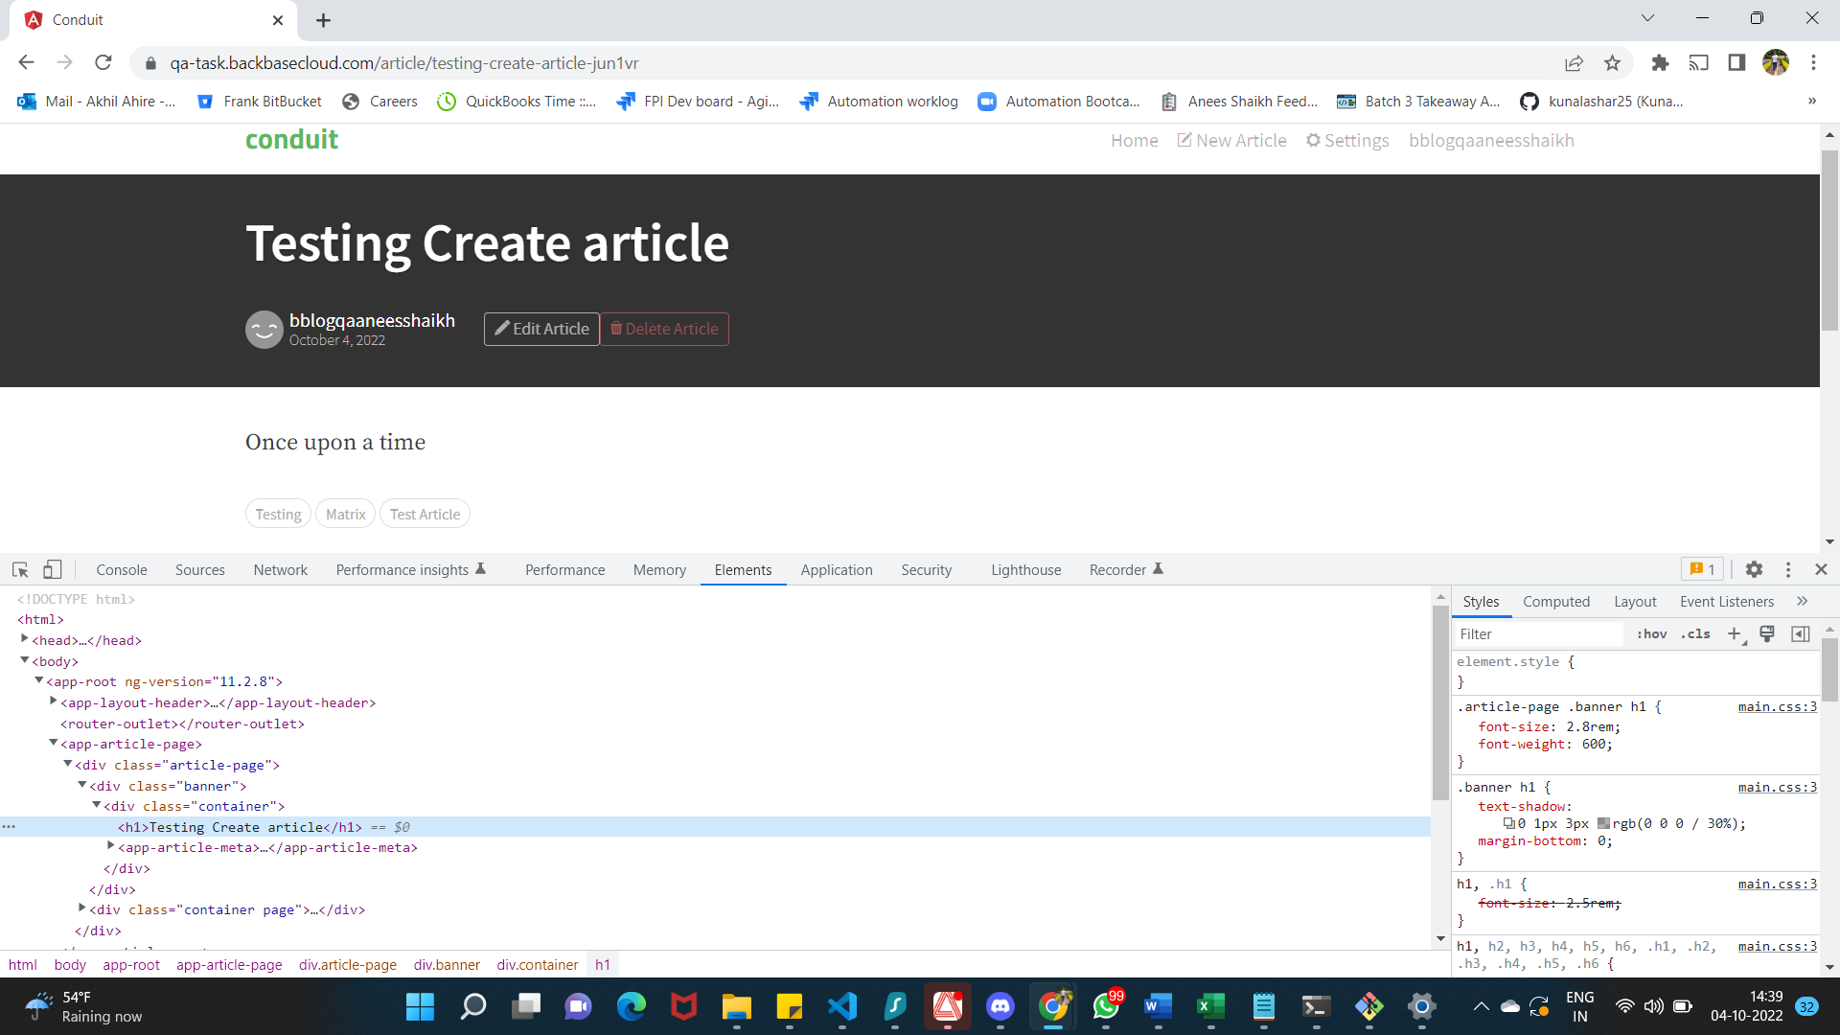

**TC_UA_001**

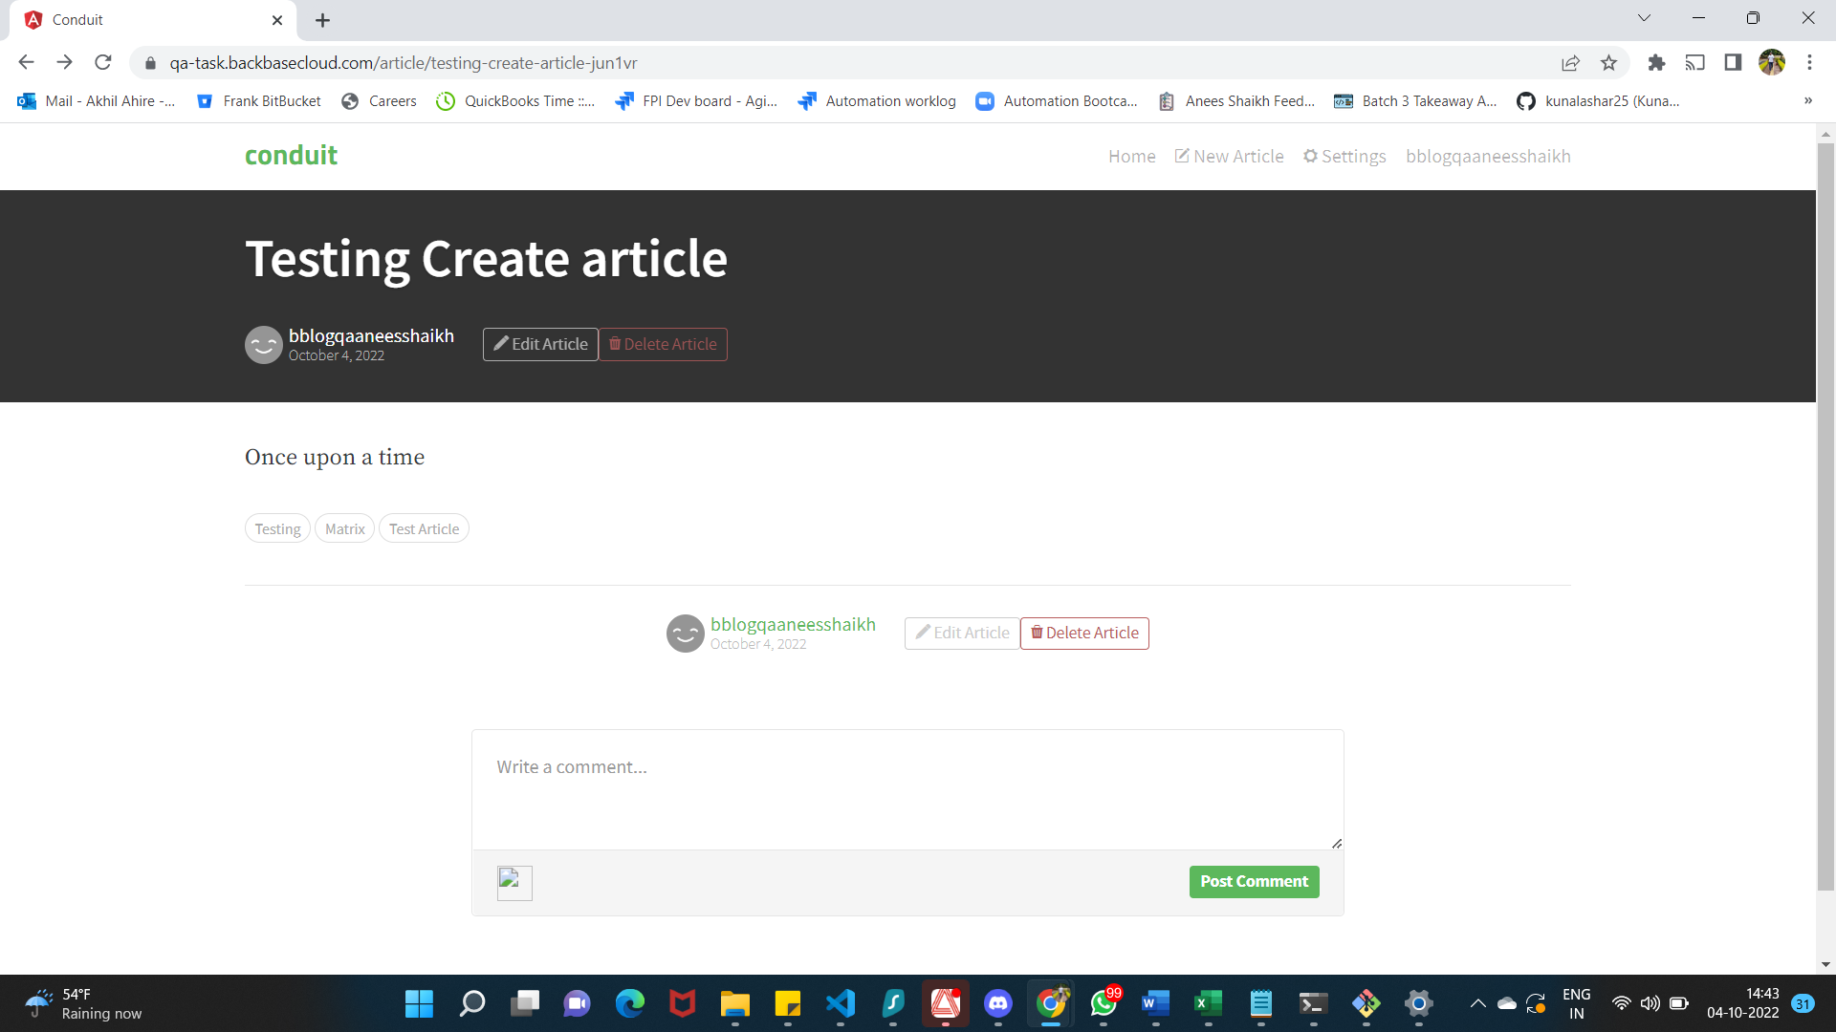

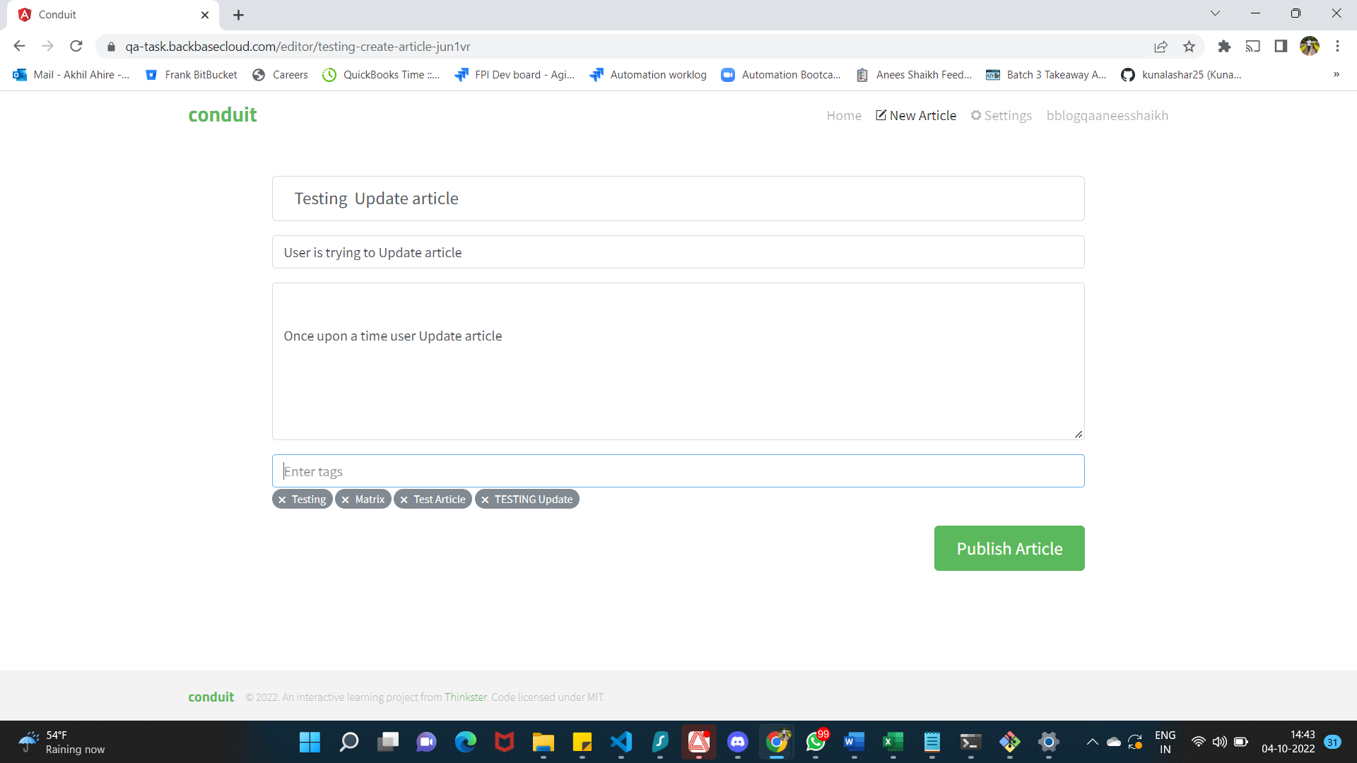

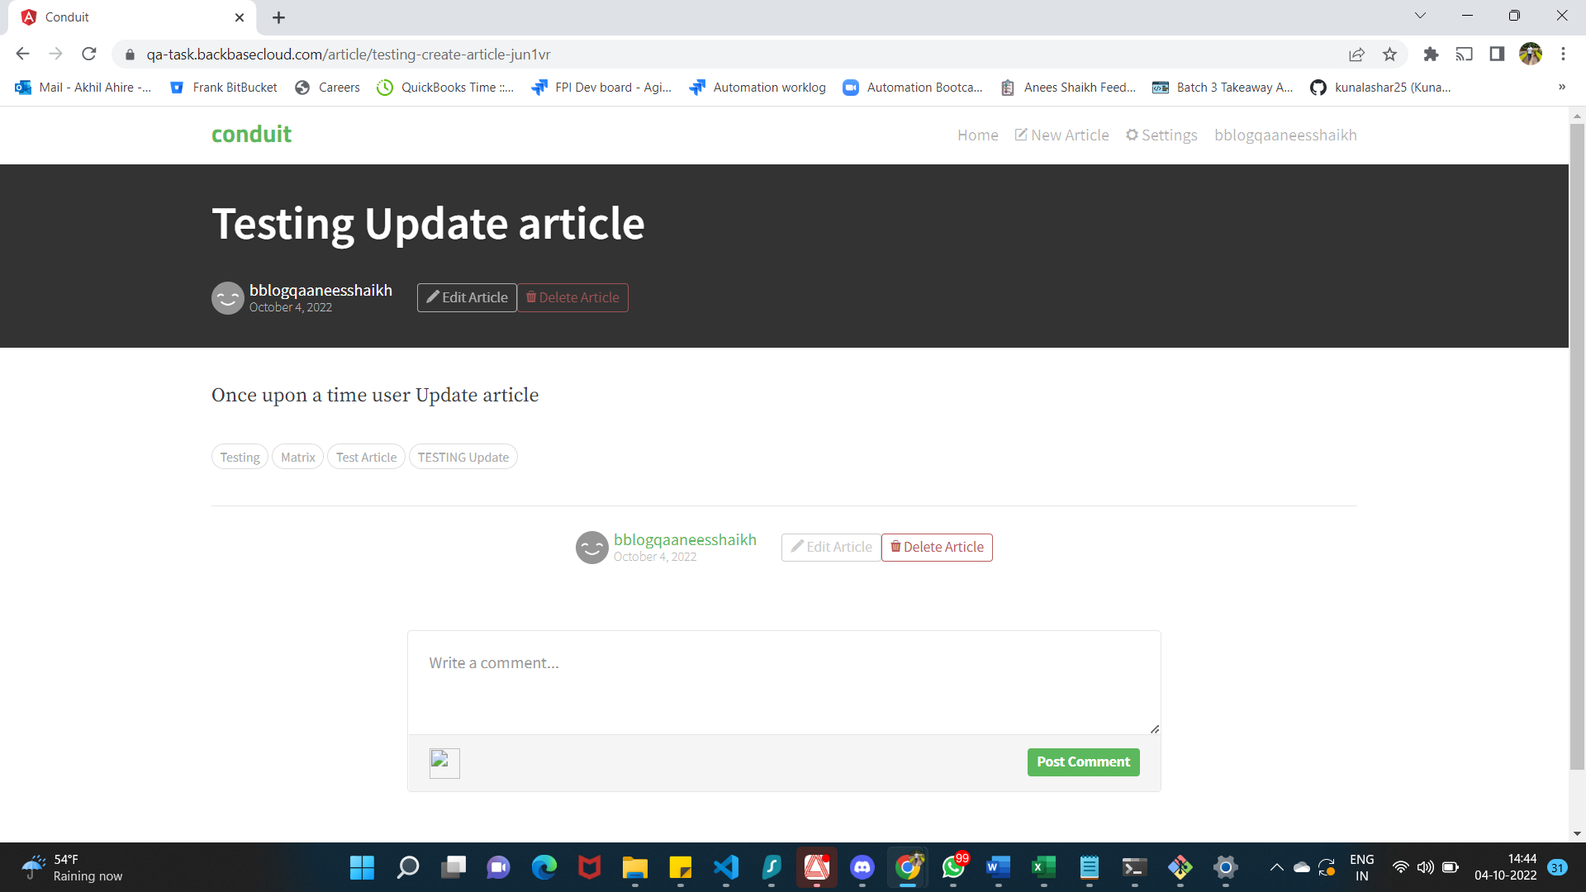

**TC_UA_002**

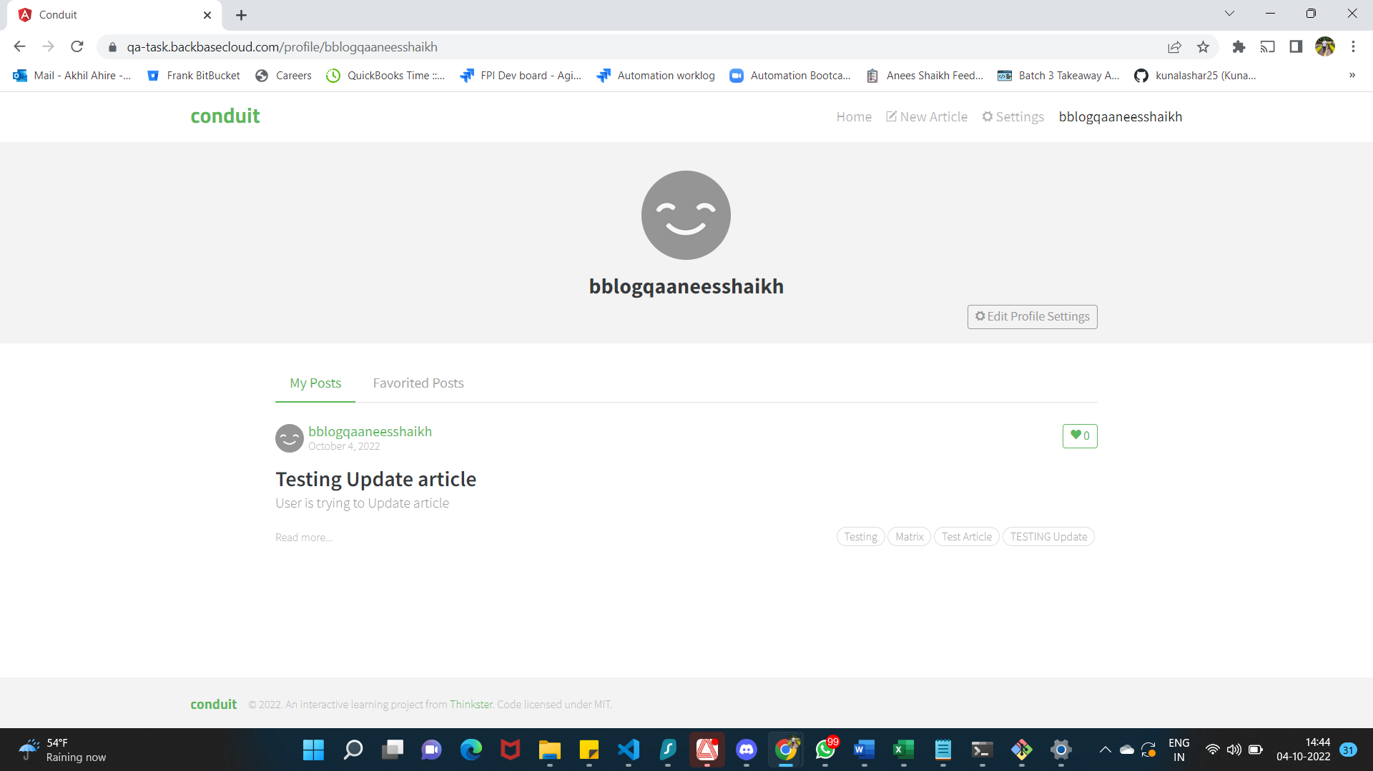

**TC_UA_003**

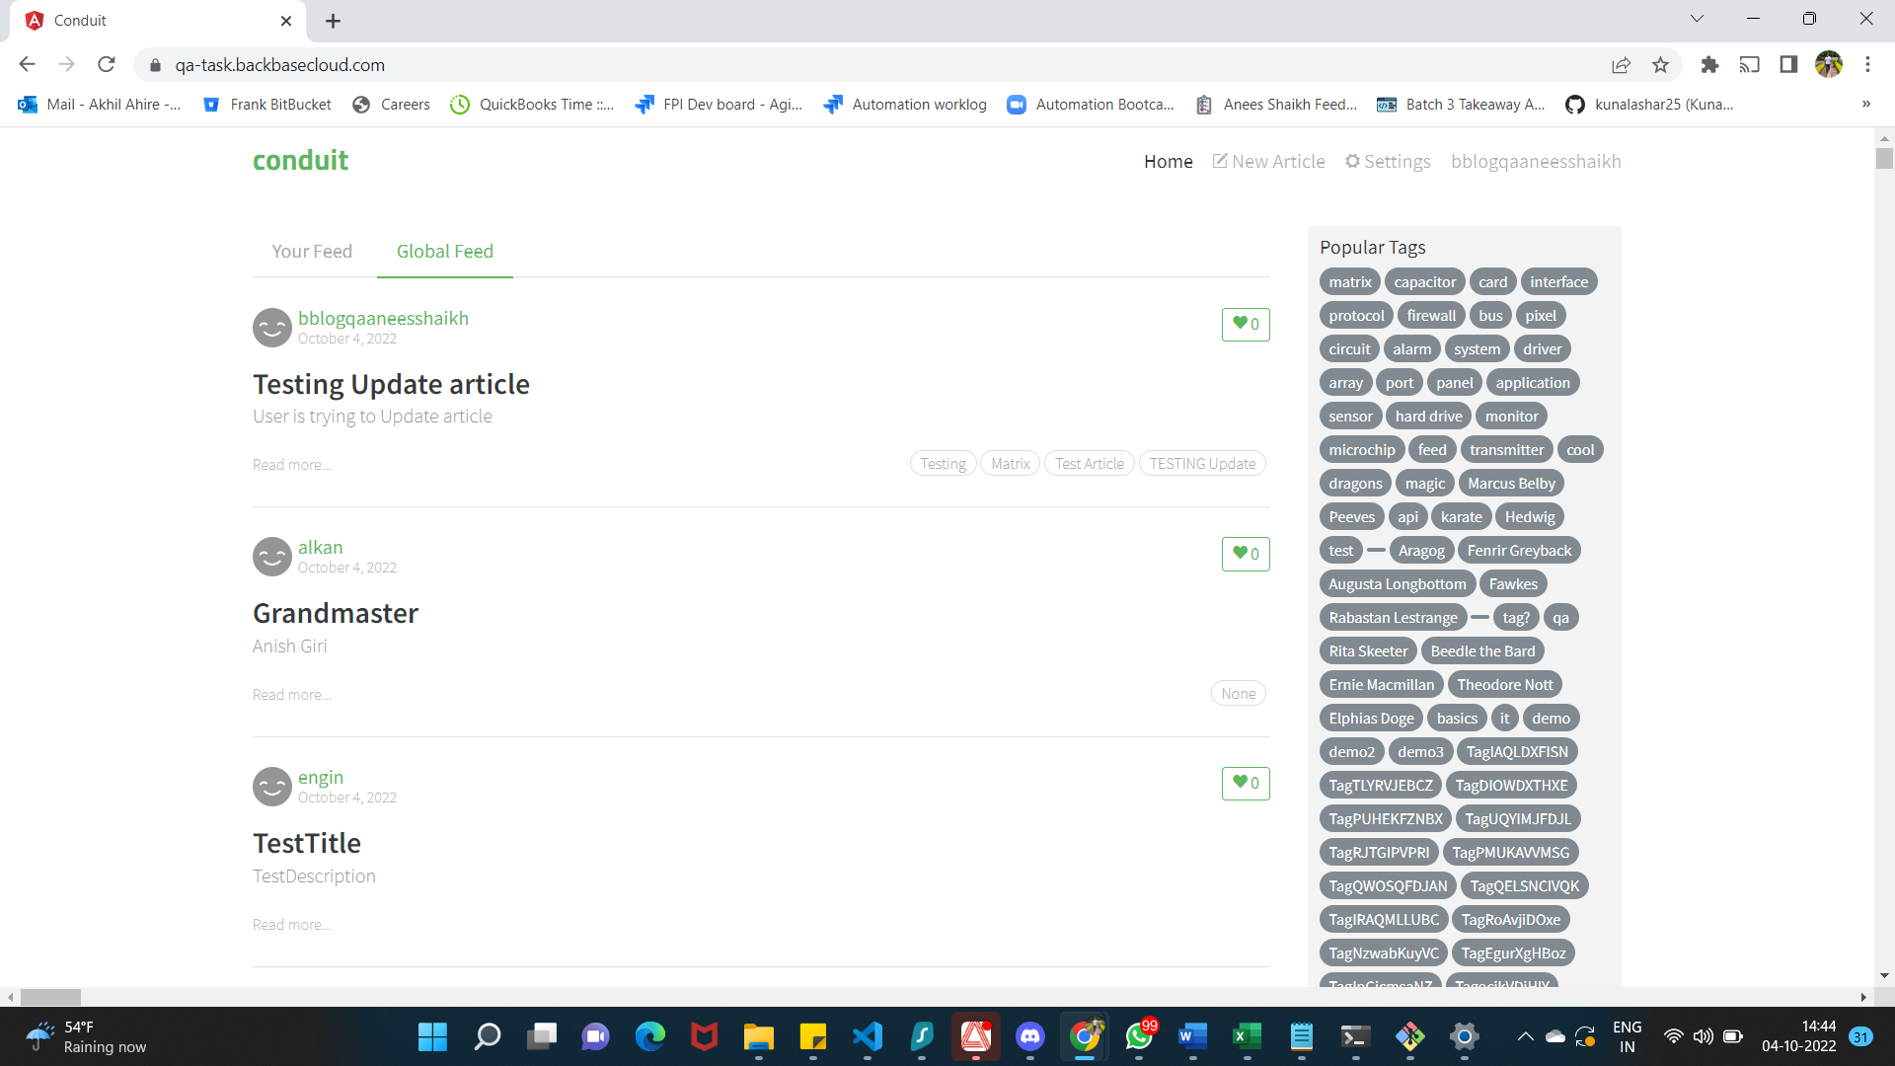

**TC_UA_004**

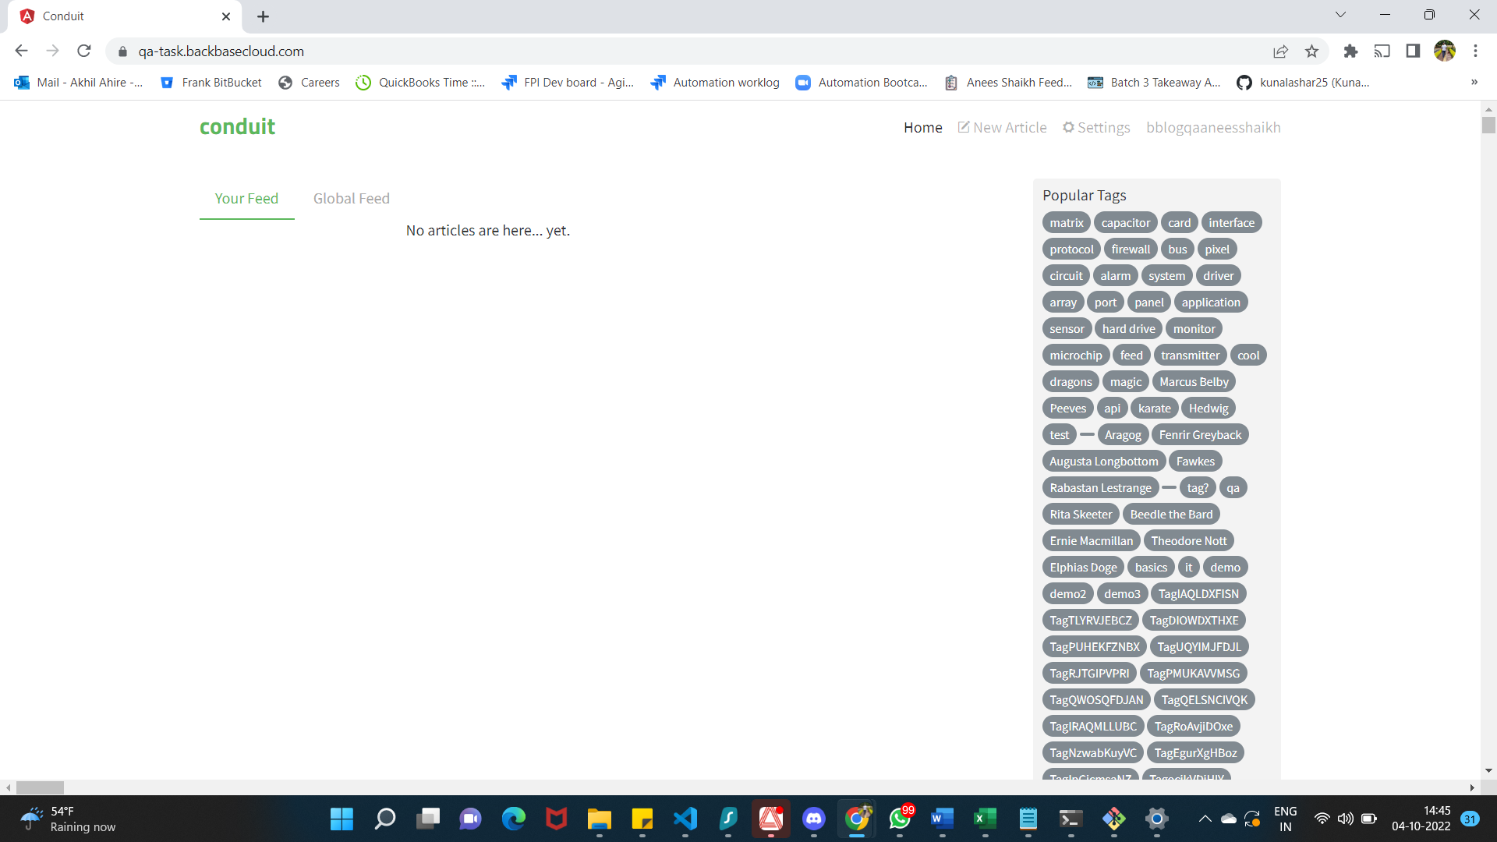

**FAILED BUG_04**

**TC_UA_005**

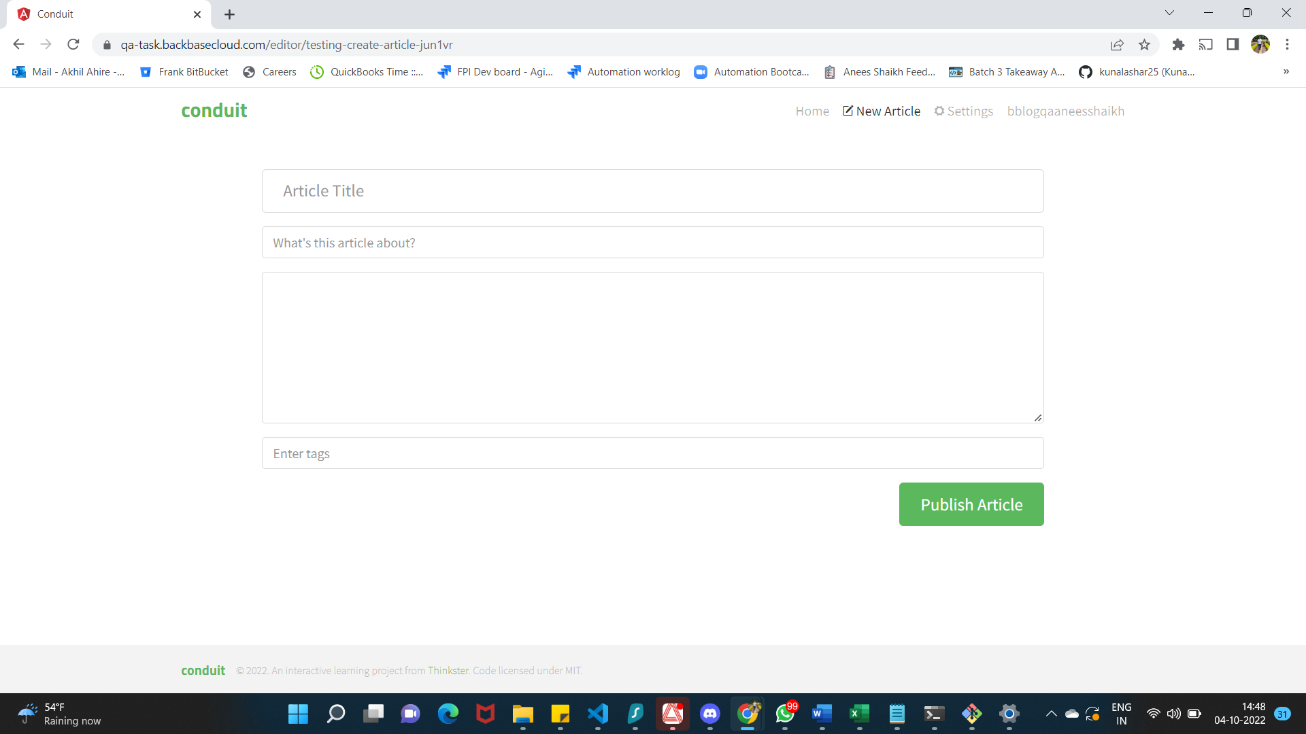

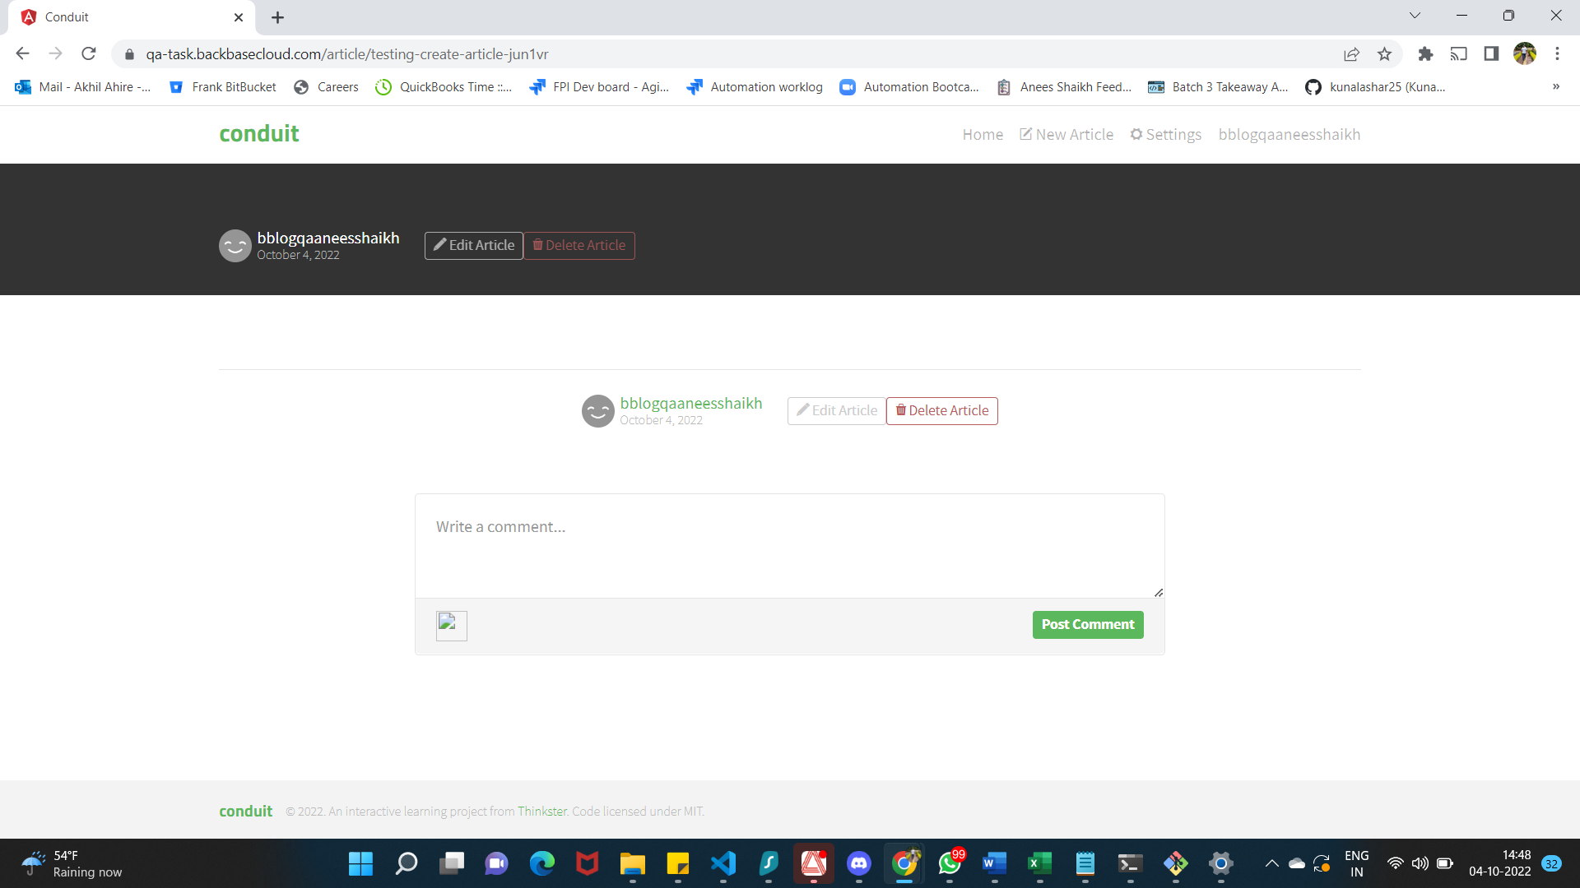

**FAILED BUG_03**

**TC_UA_006**

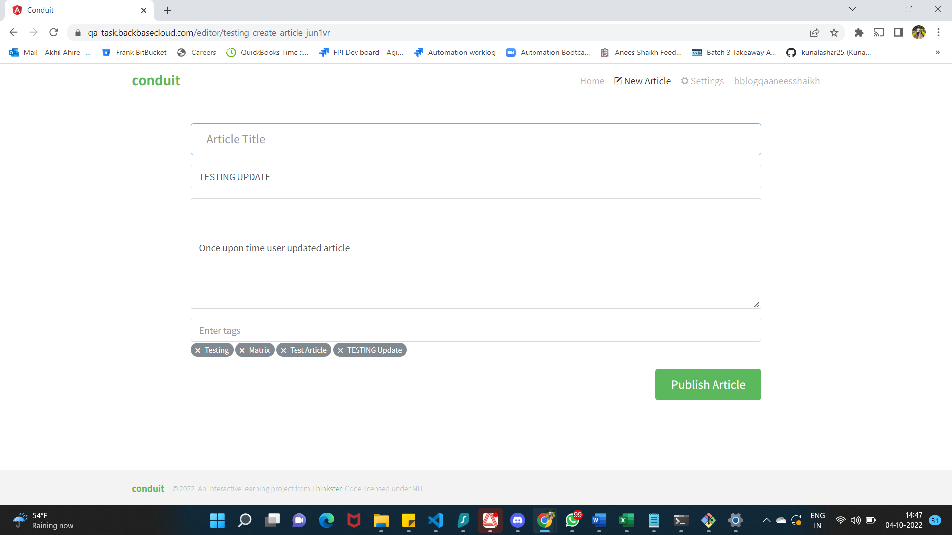

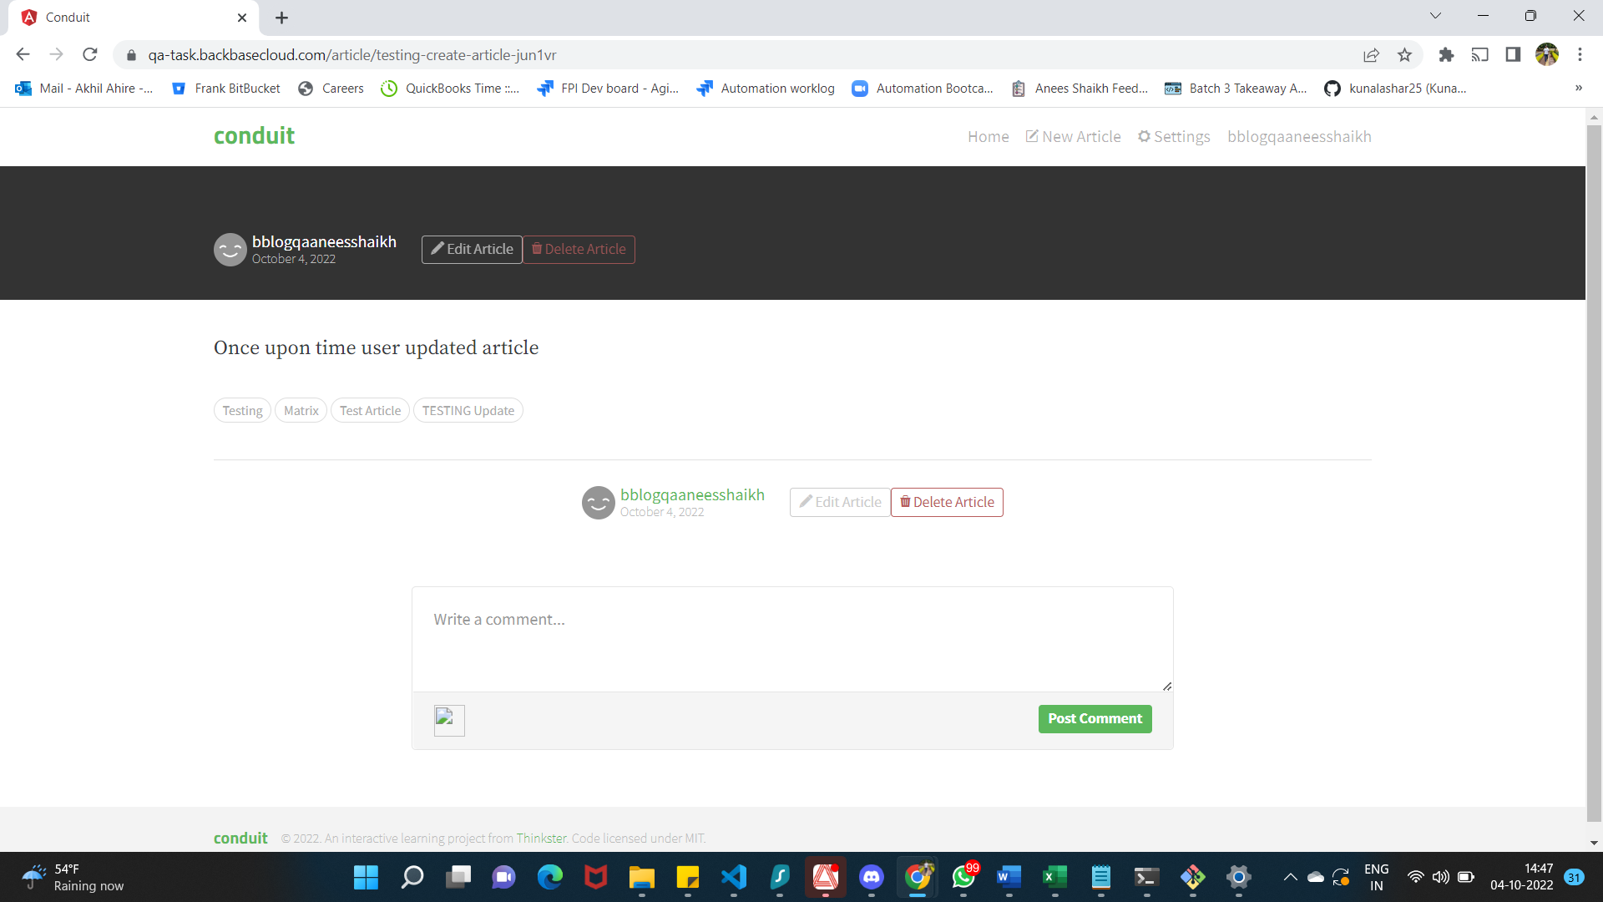

**FAILED BUG_03**

**TC_UA_007**

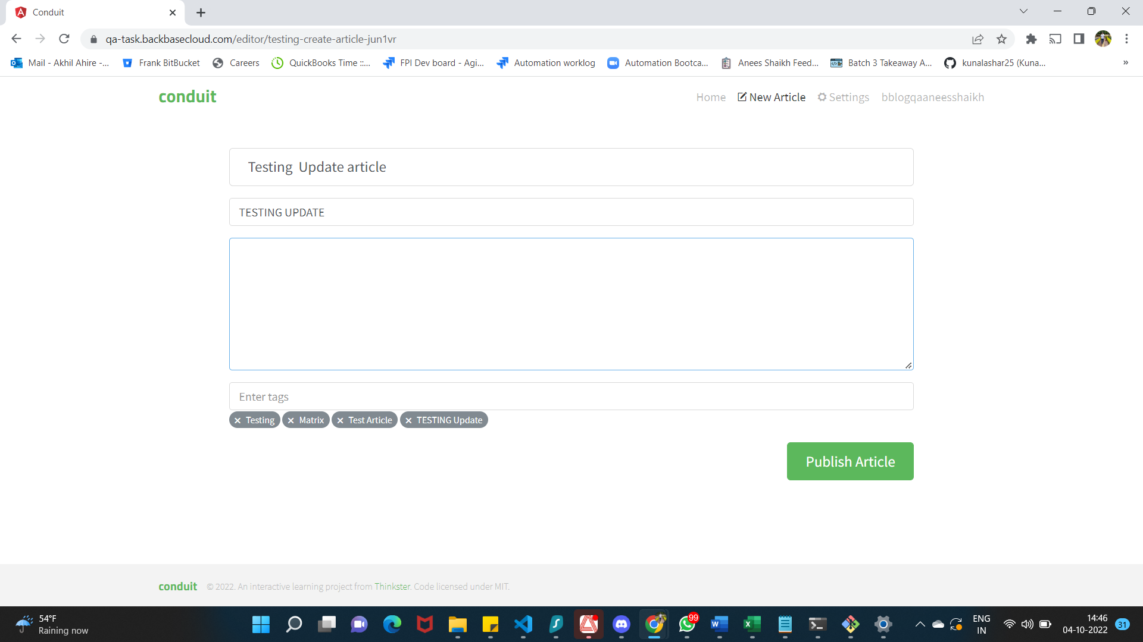

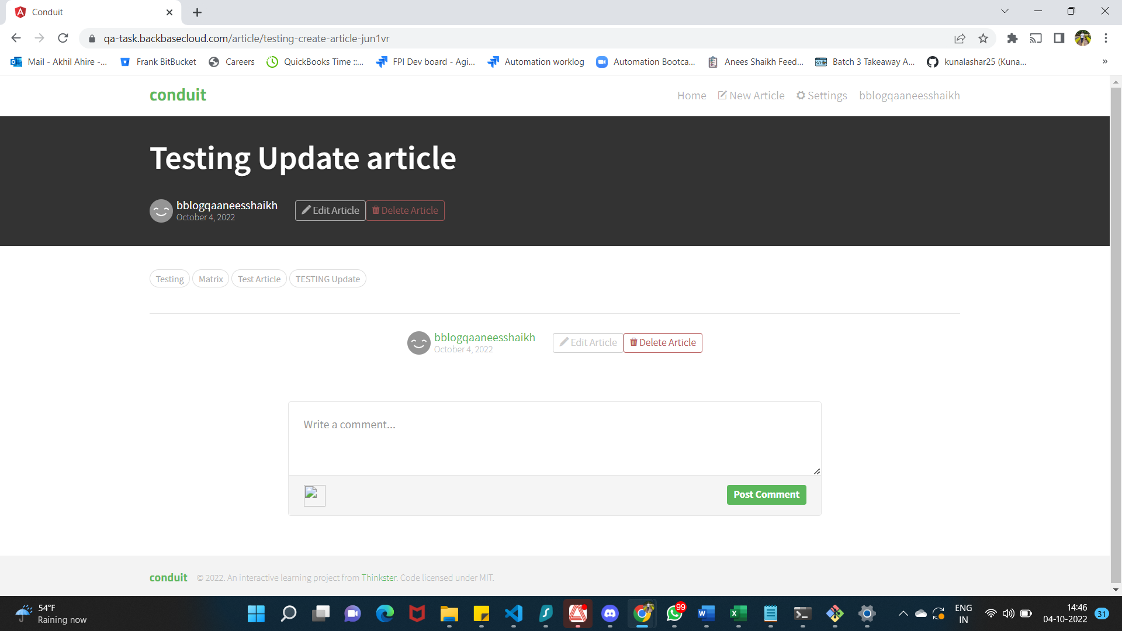

**FAILED BUG_03**

**TC_UA_008**

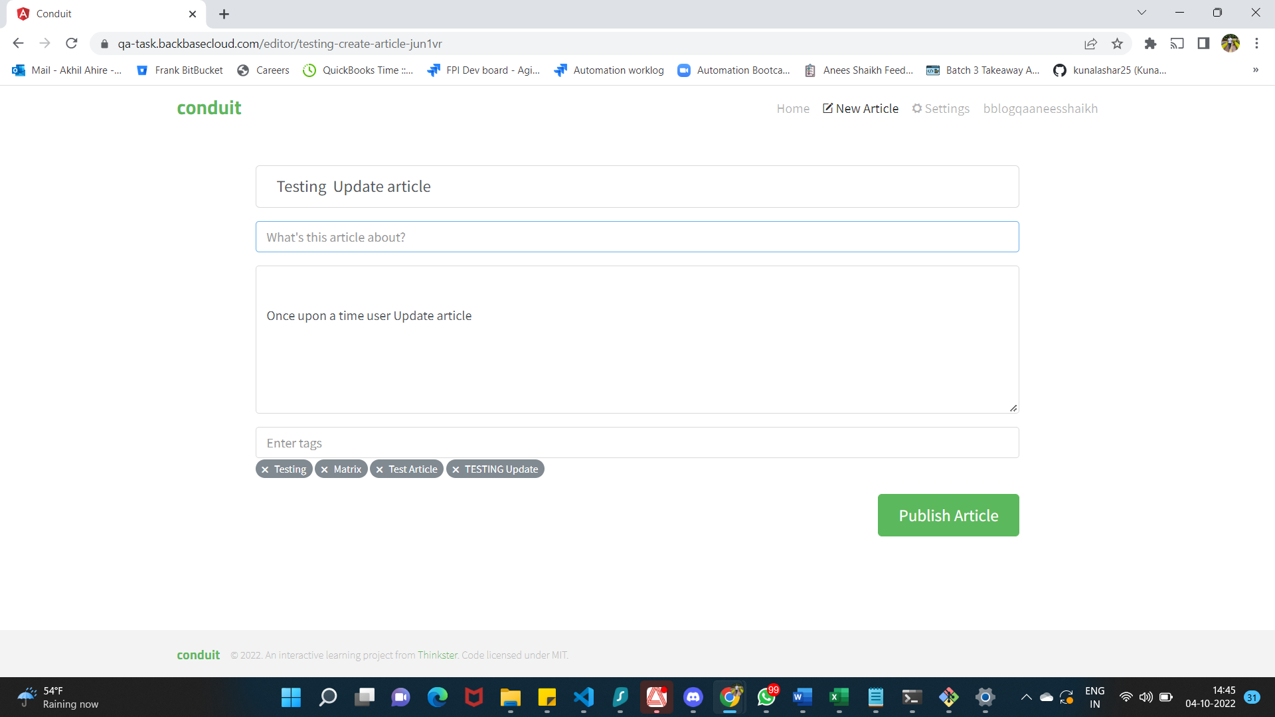 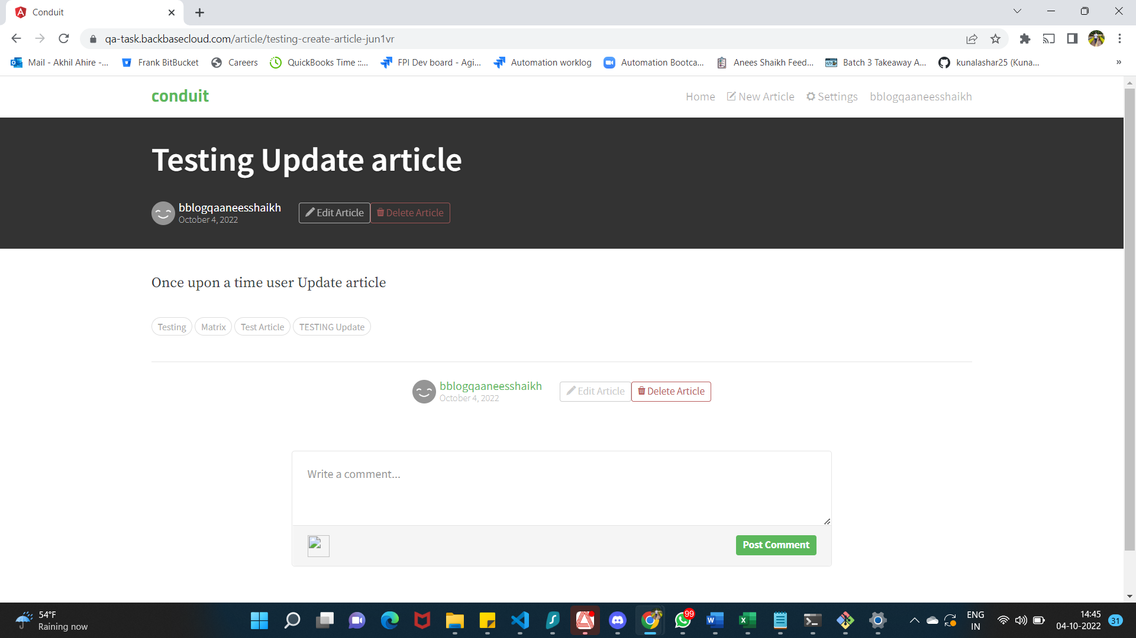

**FAILED BUG_03**

**TC_DA_001, TC_DA_002**

